**15Z010 – Open Source Systems**

**Assignment Presentation Report**

**Academic Year: 2020 – 2021 (EVEN)**

**e-Med Medical Assistance Tool**

**By**

**Sneha Sridharan (18Z252)**

**BE CSE III Year G1**

**CONTENTS**

**TOPIC PAGE NO.**

1. **PROBLEM STATEMENT 1**
2. **MODULES AND THEIR DESCRIPTION 2**
   1. LOGIN AND REGISTER MODULE 2
      1. LOGIN 2
      2. REGISTER 2
   2. PATIENT MODULE 2
      1. ADD NOTIFICATIONS 2
      2. ADD NOTES 2
      3. BOOK APPOINTMENTS 2
      4. VIEW APPOINTMENTS 3
   3. HOSPITAL MODULE 3
      1. VIEW AND CHANGE STATUS OF APPOINTMENTS 3
3. **FRONT END AND BACK END DESCRIPTION 4**
   1. FRONT END 4
      1. HTML 4
      2. CSS 4
      3. JavaScript 4
      4. Bootstrap 4
   2. WEB SERVER 4
      1. WAMP SERVER 5
   3. BACK END 5
      1. PHP 5
      2. MySQL 5
4. **CODING AND RESULTS 6**
   1. MySQL TABLES 6
   2. LOGIN AND REGISTER MODULE 9
   3. PATIENT MODULE 30
   4. HOSPITAL MODULE 64

**1.** **PROBLEM STATEMENT**

e-Med is your perfect medical friend. We often see our grandparents getting worried when they run out of medical supplies or forget their scheduled appointments. In this fast paced world with unhealthy lifestyles, a number of young people also have some medical issues. e-Med is a tool that helps keep track of and address all your personal medical needs.

Notifications can be set regarding restocking medicines, reminder about scheduling appointments, regular BP and sugar test reminders etc. The reminder will appear on the home screen on the specified date.

This system sets up a two-way communication between the users and their respective hospitals whereby the users can book appointments and get confirmation regarding the same. The tool also helps keep track of all the scheduled monthly medical appointments.

Another feature of the system is to keep a record of your medical history such as your blood sugar levels, pressure levels etc. by using the Medical Notes feature.

e-Med is an indispensable tool for people of all ages with medical issues to help maintain a good health routine.

**2. MODULES AND THEIR DESCRIPTION**

**2.1 LOGIN AND REGISTER MODULE**

Users can create a patient account or hospital account. They can then login to their accounts after specifying the user type.

**2.1.1 LOGIN**

The user can login as a patient or hospital by entering the username, password and user type – patient or hospital. If the details are correct then the user will be redirected to the home page otherwise they will be asked to try again.

**2.1.2 REGISTER**

The users can register into the system if they do not have an account by providing details like username, password and user type. The details are verified and an account is created.

**2.2 PATIENT MODULE**

In this module, users can set reminders, add medical notes, book and view appointments and take care of all their personal medical needs.

**2.2.1 ADD NOTIFICATION**

Users can set reminders to restock medicines, take medical tests at home and any other medical reminder that a user would want by feeding in the notification details and reminder date. The reminders will appear in the home screen on the specified date.

**2.2.2 ADD NOTES**

Medical history like BP, Sugar or any other information regarding the user’s health can be stored using the medical notes feature.

**2.2.3 BOOK APPOINTMENT**

Users can book an appointment in a hospital by giving details like hospital name, date and time. If all the details are correct then the appointment will be stored in the system with status as pending.

**2.2.4 VIEW APPOINTMENT**

Appointments booked by the user can be viewed here. Status – Pending, Confirmed, Unavailable can be verified.

**2.3 HOSPITAL MODULE**

The website also has a provision for the hospital to note the appointments booked by users of this system and change their status depending on availability.

**2.3.1 VIEW AND CHANGE STATUS OF APPOINTMENT**

The status of the appointments can be changed from the default status of Pending to Confirmed or Unavailable accordingly.

**3 FRONT END AND BACK END DESCRIPTION**

**3.1 FRONT-END**

Front-end web development also called client side web development is the practice of using HTML, CSS and JavaScript to build a website for users to easily interact with data and perform various actions online. The following languages were used to design the front-end of the project:

**3.1.1 HTML**

HTML (Hyper Text Markup Language) is the standard markup language for documents that are meant to be displayed in a browser. It defines the meaning and structure of web content.

**3.1.2 CSS**

Cascading Style Sheets (CSS) are used to style HTML documents. to plan the configuration of site pages. It is used to provide layout, apply different fonts, put background images, give margin and padding etc. to the content displayed on a web page.

**3.1.3 JavaScript**

JavaScript adds a lot more functionality to a basic HTML website. Basic web applications can be created with just HTML, CSS and JavaScript. It can be used to display alert pop ups, to change the content in the web page based on user action.

**3.1.4 Bootstrap**

Bootstrap is one of the most popular CSS framework to develop responsive and mobile first websites. The main purpose of adding it to a web project is to apply Bootstrap's choices of colour, size, font and layout to that project.

**3.2 WEB SERVER**

A web server uses HTML and other protocols to respond to client requests made over the World Wide Web.

**3.2.1 WAMP SERVER**

WAMP Stands for "Windows, Apache, MySQL, and PHP." The most important part of the WAMP package is Apache which is used run the web server within Windows. By running a local Apache web server on a Windows machine, a web developer can test webpages in a web browser without publishing them live on the Internet.

**3.3 BACK-END**

The back end development is the server side development. It mainly consists of a database that stores all the details pertaining to the website. These details can be accessed in the front end by using back end code. The following tools were used for back-end design:

**3.3.1 PHP**

PHP which is "PHP: Hypertext Preprocessor" is an open-source scripting language used in the server side. It can be integrated with databases and is processed on a web server. The executed PHP code forms the whole or part of a HTTP response.

**3.3.2 MySQL**

MySQL is an open-source relational database management system based on SQL. The application can be used to store anything from a single record of information to an entire inventory and is typically used to store all the data required by a website.

**4. CODING AND RESULTS**

**4.1 MySQL TABLES**

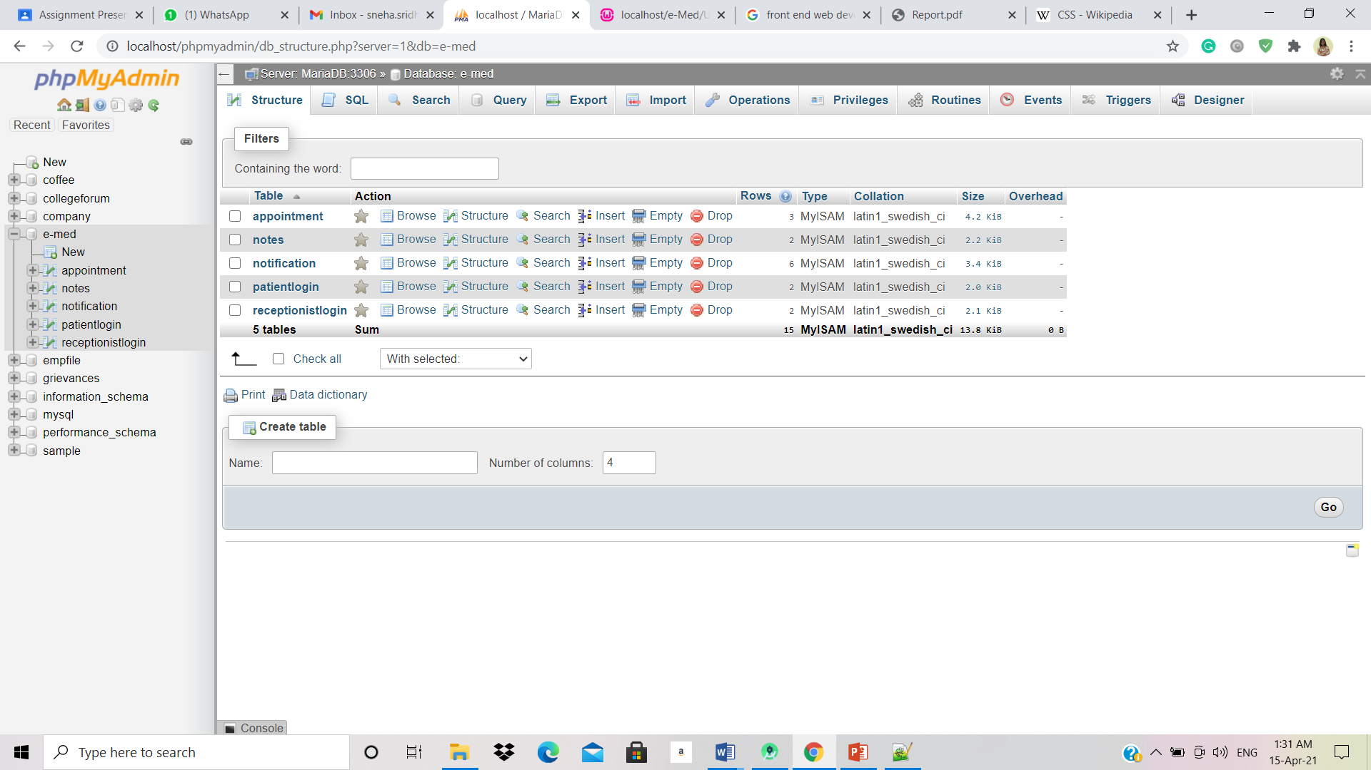

**Fig 1:** Tables used in this e-Med project.

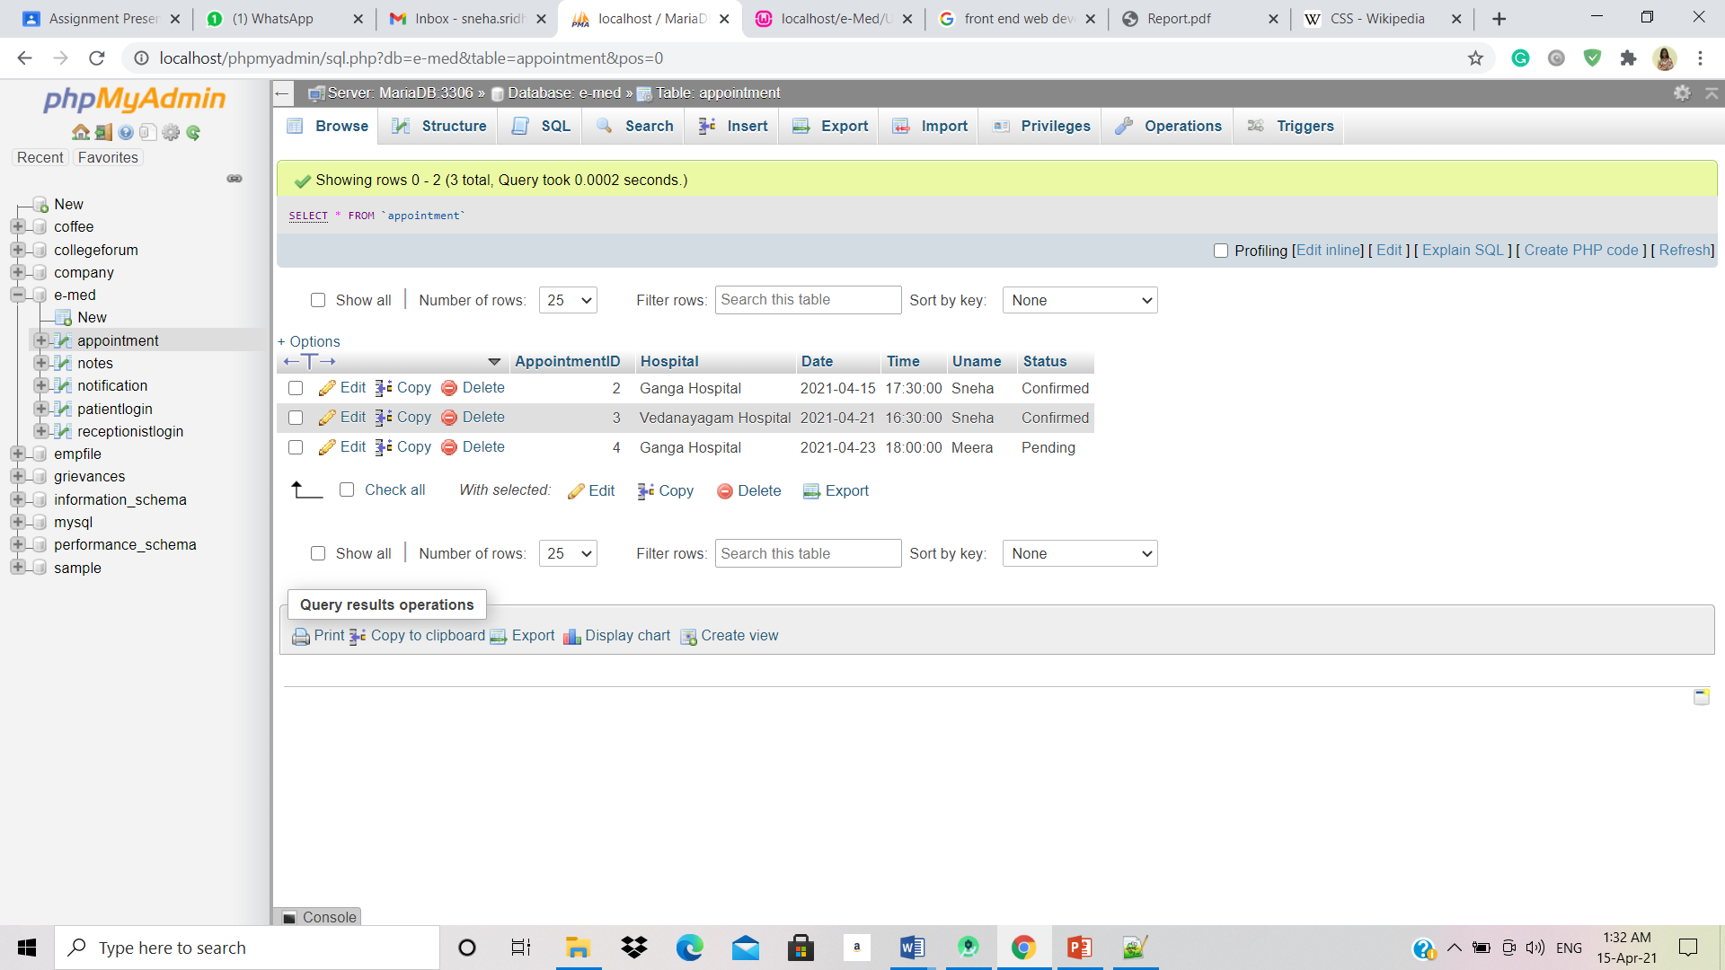

**Fig 2:** Appointment Table

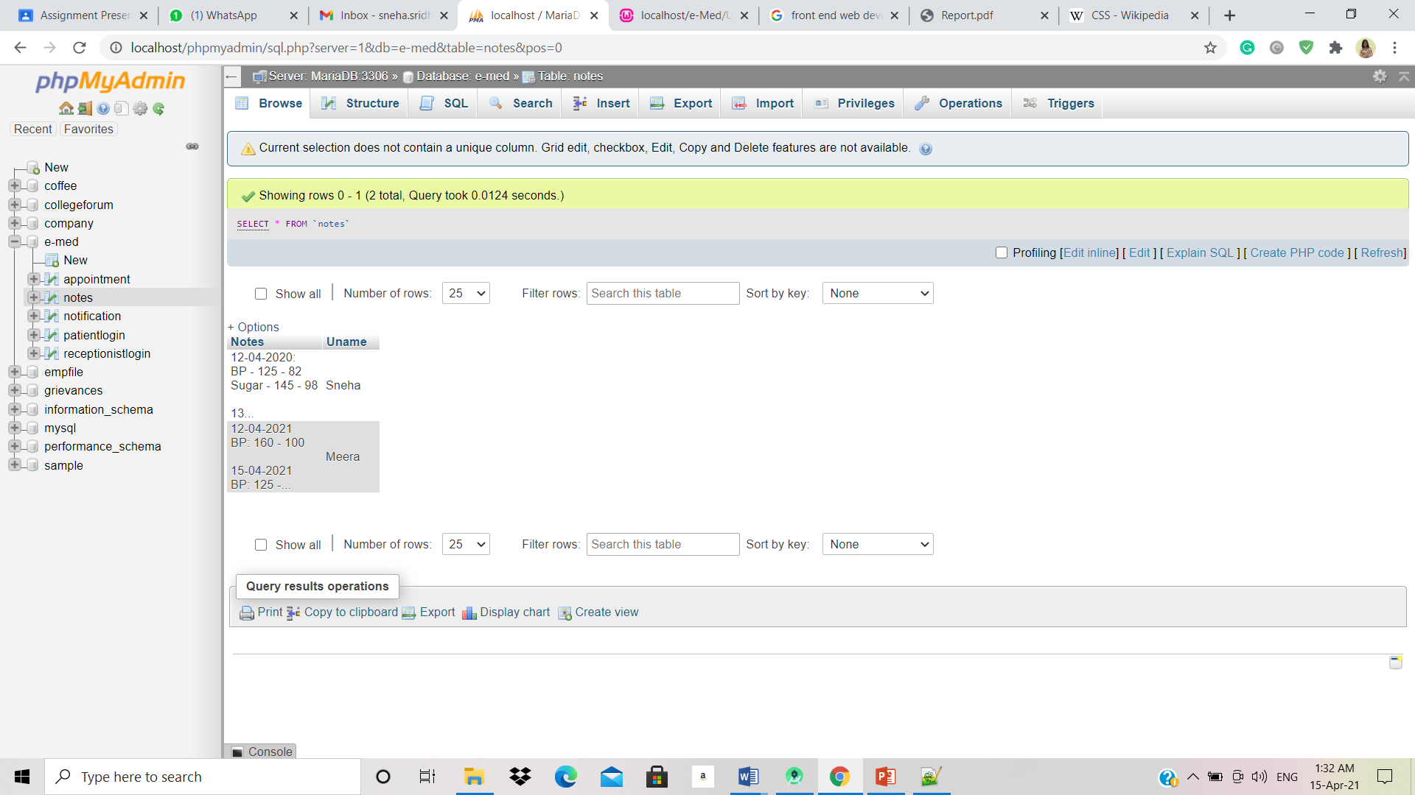

**Fig 3:** Notes Table

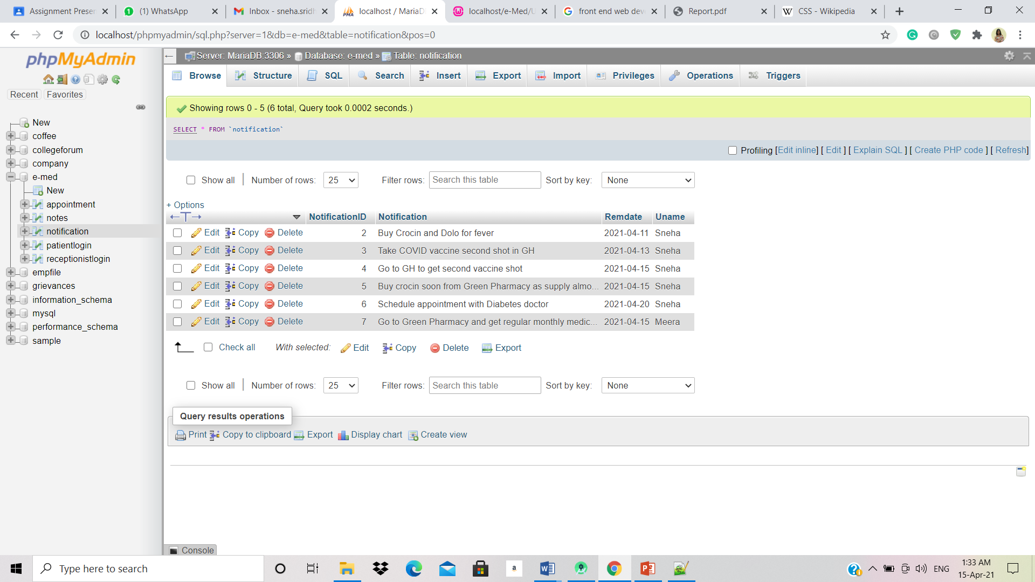

**Fig 4:** Notification Table

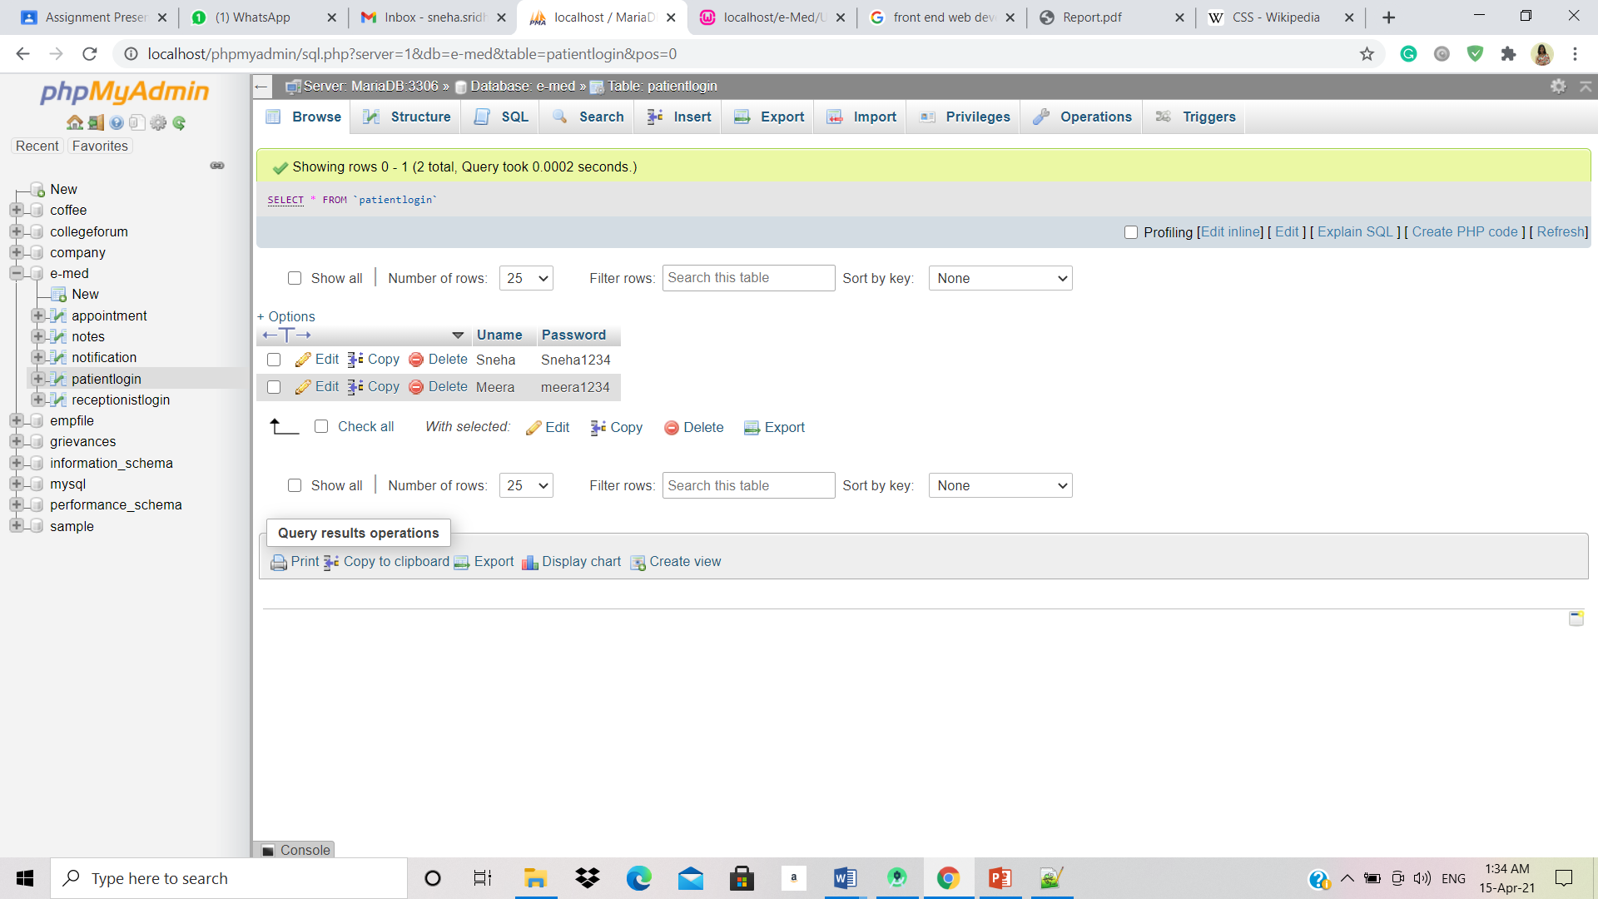

**Fig 5:** Patient Login Table

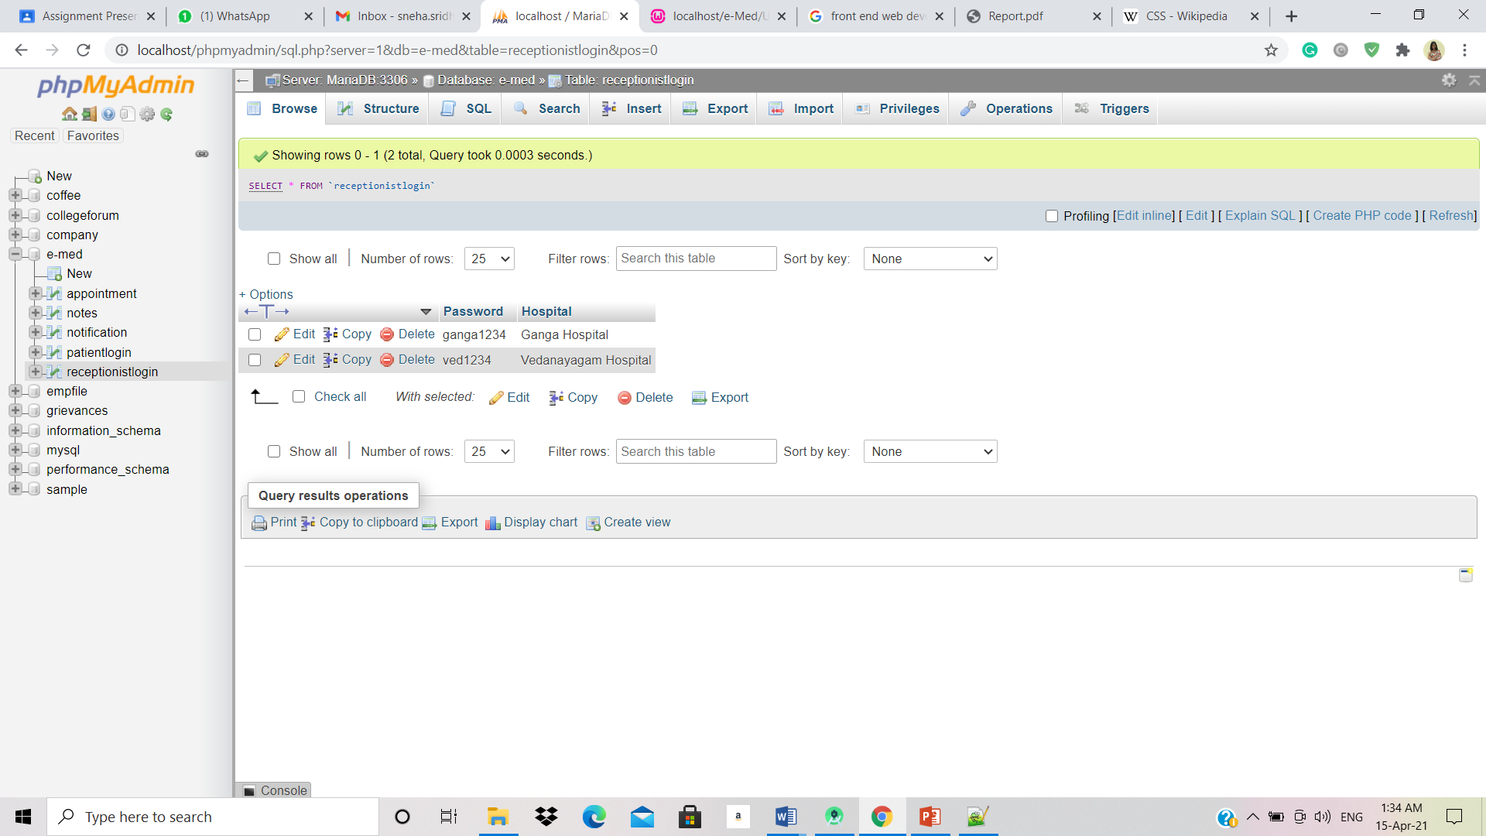

**Fig 6:** Receptionist Login Table

**4.2 LOGIN AND REGISTER MODULE**

**Login**

<?php

session_start();

if(isset($_SESSION['login_error']))

{

echo '<script type="text/javascript">window.onload = function(){alert("Please enter correct details")};</script>';

unset($_SESSION['login_error']);

}

?>

<!DOCTYPE html>

<html>

<head>

<meta name="viewport" content="width=device-width, initial-scale=1">

<link rel="stylesheet" href="https://maxcdn.bootstrapcdn.com/bootstrap/3.4.1/css/bootstrap.min.css">

<script src="https://ajax.googleapis.com/ajax/libs/jquery/3.5.1/jquery.min.js"></script>

<script src="https://maxcdn.bootstrapcdn.com/bootstrap/3.4.1/js/bootstrap.min.js"></script>

<link rel="preconnect" href="https://fonts.gstatic.com">

<link href="https://fonts.googleapis.com/css2?family=Lato:wght@400&display=swap" rel="stylesheet">

<style>

.column {

width:80%;

color:black;

margin-left:80px;

}

body

{

background-color: #EEEEFF;

background-image:url('stethoscope.jpg');

background-attachment:fixed;

background-size:50% 100%;

background-repeat:no-repeat;

font-family: 'Lato', sans-serif;

}

input[type="submit"]{

border-radius: 10px;

height:50px;

width: 100%;

background-color:#00008b;

color:white;

font-size:22px;

}

input[type="submit"]:hover{

border: #9932cc;

background-color: #0000cd;

cursor: pointer;

transition:0.6s;

}

input, select{

display:block;

width: 100%;

height: 50px;

padding: 5px 1px;

font-size:16px;

border-radius:10px;

outline:none; margin: 5px 0 22px 0;

border: none;

background: #ffffff;

font-size:18px;

}

input:focus, textarea:focus, select:focus{

border: 2px solid #bbbbbb;

background: #f5f5f5;

transition: .6s;

outline:none;

}

form{

font-size:20px;

}

</style>

</head>

<body>

<div class="row">

<div class="col-sm-6">

</div>

<div class="col-sm-6" style="position: fixed;top: 11%;left: 50%;">

<div class="column">

<h1 style="text-align:center;color:#00005b;">LOGIN</h1><br>

<form method="POST" action="logintest.php">

User Type

<select id="type" name="type" required>

<div class="dropdown-content">

<option disabled selected value> ---- Select User Type ---- </option>

<option value="patient">Patient</option>

<option value="receptionist">Hospital</option>

</div>

</select>

<br>

Username

<input type="text" name="username" required>

Password

<input type="password" name="password" required>

<p style="display:inline-block">New User?</p>

<a style="text-decoration:none" href="Registerpatient.php">

Register as Patient</a>

<p style="display:inline-block">or</p>

<a style="text-decoration:none" href="Registerreceptionist.php">

Register as Hospital</a><br><br>

<input type="submit" name="submit" value="LOGIN">

</form>

</div>

</div>

</div>

</body>

</html>

**Login Test**

<html>

<body>

<?php

session_start();

$servername="localhost";

$username="root";

$password="";

$dbname="e-med";

$conn=new mysqli($servername,$username,$password,$dbname);

if (!$conn)

{

die('Could not connect: ' . mysql_error());

}

if(isset($_POST['submit']))

{

$utype=$_POST['type'];

$uname=$_POST['username'];

$pwd=$_POST['password'];

if($utype=="patient")

{

$sql="select * from patientlogin WHERE Uname = '$uname' and Password = '$pwd'";

$result=$conn->query($sql);

if(mysqli_num_rows($result)==1)

{

$_SESSION['username'] = $uname;

header('Location:UserHome.php');

}

else

{

$_SESSION['login_error'] = 1;

header('Location:Login.php');

}

}

else

{

$sql="select * from receptionistlogin WHERE Hospital = '$uname' and Password = '$pwd'";

$result=$conn->query($sql);

if(mysqli_num_rows($result)==1)

{

$_SESSION['username'] = $uname;

header('Location:ReceptionistHome.php');

}

else

{

$_SESSION['login_error'] = 1;

header('Location:Login.php');

}

}

}

$conn->close();

?>

</body>

</html>

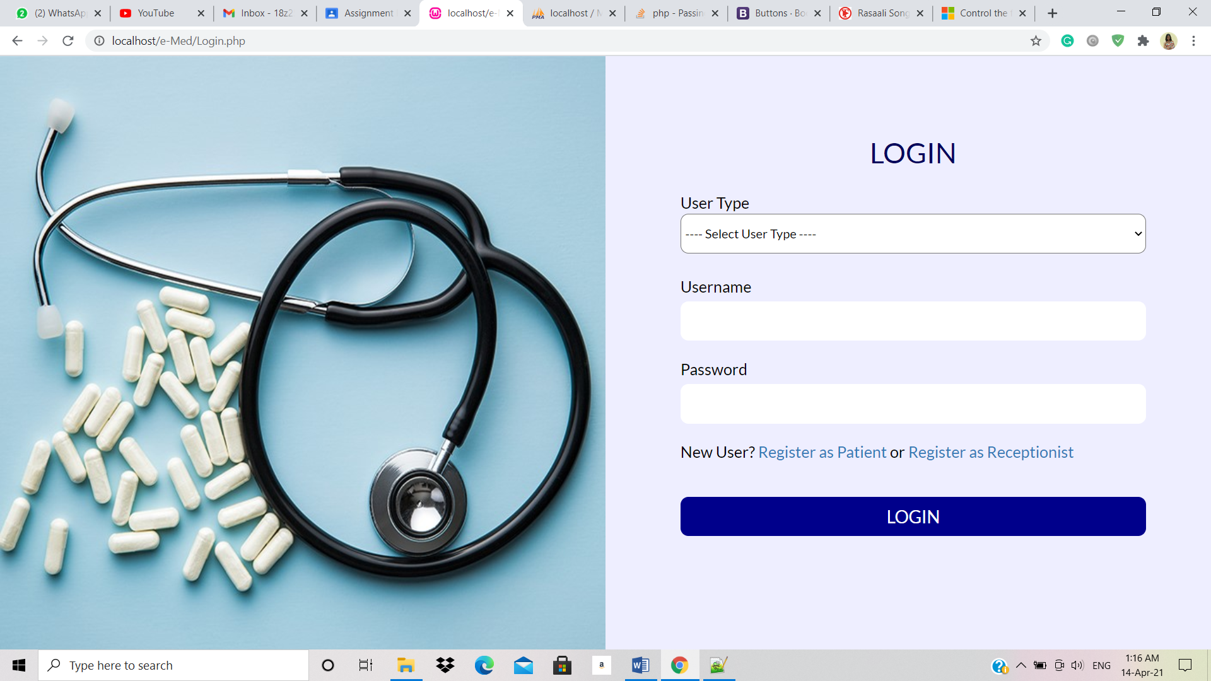

**Fig 7:** This is the login page for users to log in to the app.

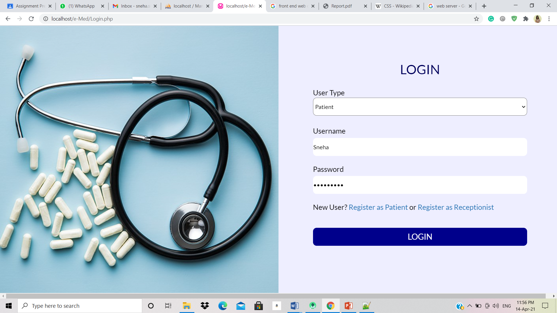

**Fig 8:** After typing all the details and selecting the user type, users will be allowed to log in to the system and will be redirected to the home page.

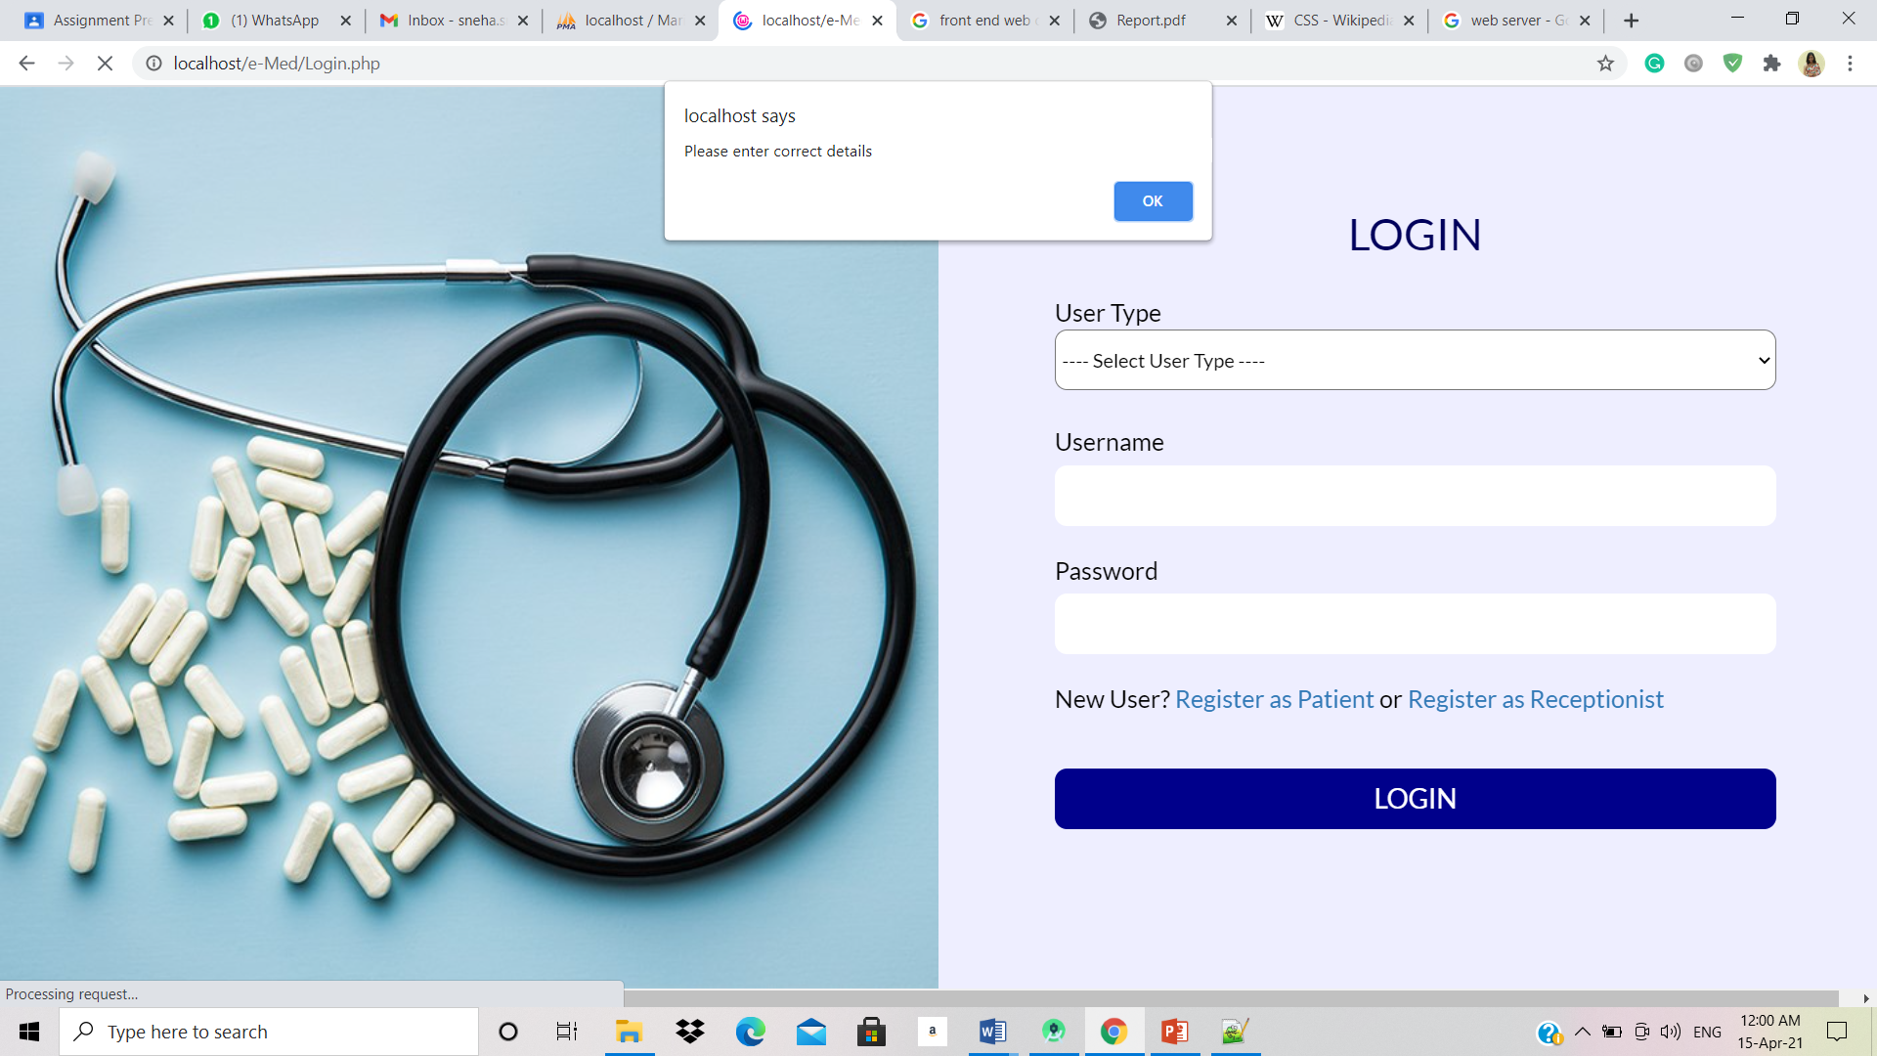

**Fig 9:** If the details are incorrect then the users will be prompted to enter correct details.

**Register Patient**

<?php

session_start();

if(isset($_SESSION['register_error1']))

{

echo '<script type="text/javascript">window.onload = function(){alert("Failed to register")};</script>';

unset($_SESSION['register_error1']);

}

if(isset($_SESSION['register_error2']))

{

echo '<script type="text/javascript">window.onload = function(){alert("Password and confirm password does not match")};</script>';

unset($_SESSION['register_error2']);

}

?>

<!DOCTYPE html>

<html>

<head>

<meta name="viewport" content="width=device-width, initial-scale=1">

<link rel="stylesheet" href="https://maxcdn.bootstrapcdn.com/bootstrap/3.4.1/css/bootstrap.min.css">

<script src="https://ajax.googleapis.com/ajax/libs/jquery/3.5.1/jquery.min.js"></script>

<script src="https://maxcdn.bootstrapcdn.com/bootstrap/3.4.1/js/bootstrap.min.js"></script>

<link rel="preconnect" href="https://fonts.gstatic.com">

<link href="https://fonts.googleapis.com/css2?family=Lato:wght@400&display=swap" rel="stylesheet">

<style>

.column {

width:80%;

color:black;

margin-left:80px;

}

body

{

background-color: #EEEEFF;

background-image:url('stethoscope.jpg');

background-attachment:fixed;

background-size:50% 100%;

background-repeat:no-repeat;

font-family: 'Lato', sans-serif;

}

input[type="submit"]{

border-radius: 10px;

height:50px;

width: 100%;

background-color:#00008b;

color:white;

font-size:22px;

}

input[type="submit"]:hover{

border: #9932cc;

background-color: #0000cd;

cursor: pointer;

transition:0.6s;

}

input, select{

display:block;

width: 100%;

height: 50px;

padding: 5px 1px;

font-size:16px;

border-radius:10px;

outline:none;

margin: 5px 0 22px 0;

border: none;

background: #ffffff;

font-size:18px;

}

input:focus, textarea:focus, select:focus{

border: 2px solid #bbbbbb;

background: #f5f5f5;

transition: .6s;

outline:none;

}

form{

font-size:20px;

}

</style>

</head>

<body>

<div class="row">

<div class="col-sm-6">

</div>

<div class="col-sm-6" style="position: fixed; top: 11%; left: 50%;">

<div class="column">

<h1 style="text-align:center;color:#00005b;">REGISTER</h1><br>

<form method="POST" action="registerpattest.php">

Name

<input type="text" name="username" required>

Password

<input type="password" name="password" required>

Confirm Password

<input type="password" name="conf-pass" required>

<a style="text-decoration:none" href="Login.php" id="forgot">Already a user? Login</a><br><br>

<input type="submit" name="submit" value="REGISTER">

</form>

</div>

</div>

</div>

</body>

</html>

**Register Patient Test**

<?php

session_start();

$servername="localhost";

$username="root";

$password="";

$dbname="e-med";

$conn=new mysqli($servername,$username,$password,$dbname);

if (!$conn)

{

die('Could not connect: ' . mysql_error());

}

if(isset($_POST['submit']))

{

$uname=$_POST['username'];

$pwd=$_POST['password'];

$conf=$_POST['conf-pass'];

if($pwd==$conf)

{

$sql="insert into patientlogin(Uname, Password) values('$uname','$pwd')";

$result=$conn->query($sql);

$error1="Failed to register";

$error2="Password and confirm password does not match";

if($result)

{

$_SESSION['username'] = $uname;

header('location:UserHome.php');

}

else

{

$_SESSION['register_error']=$error1;

header('location:Registerpatient.php');

}

}

else

{

$_SESSION['register_error']=$error2;

header('location:Registerpatient.php');

}

}

$conn->close();

?>

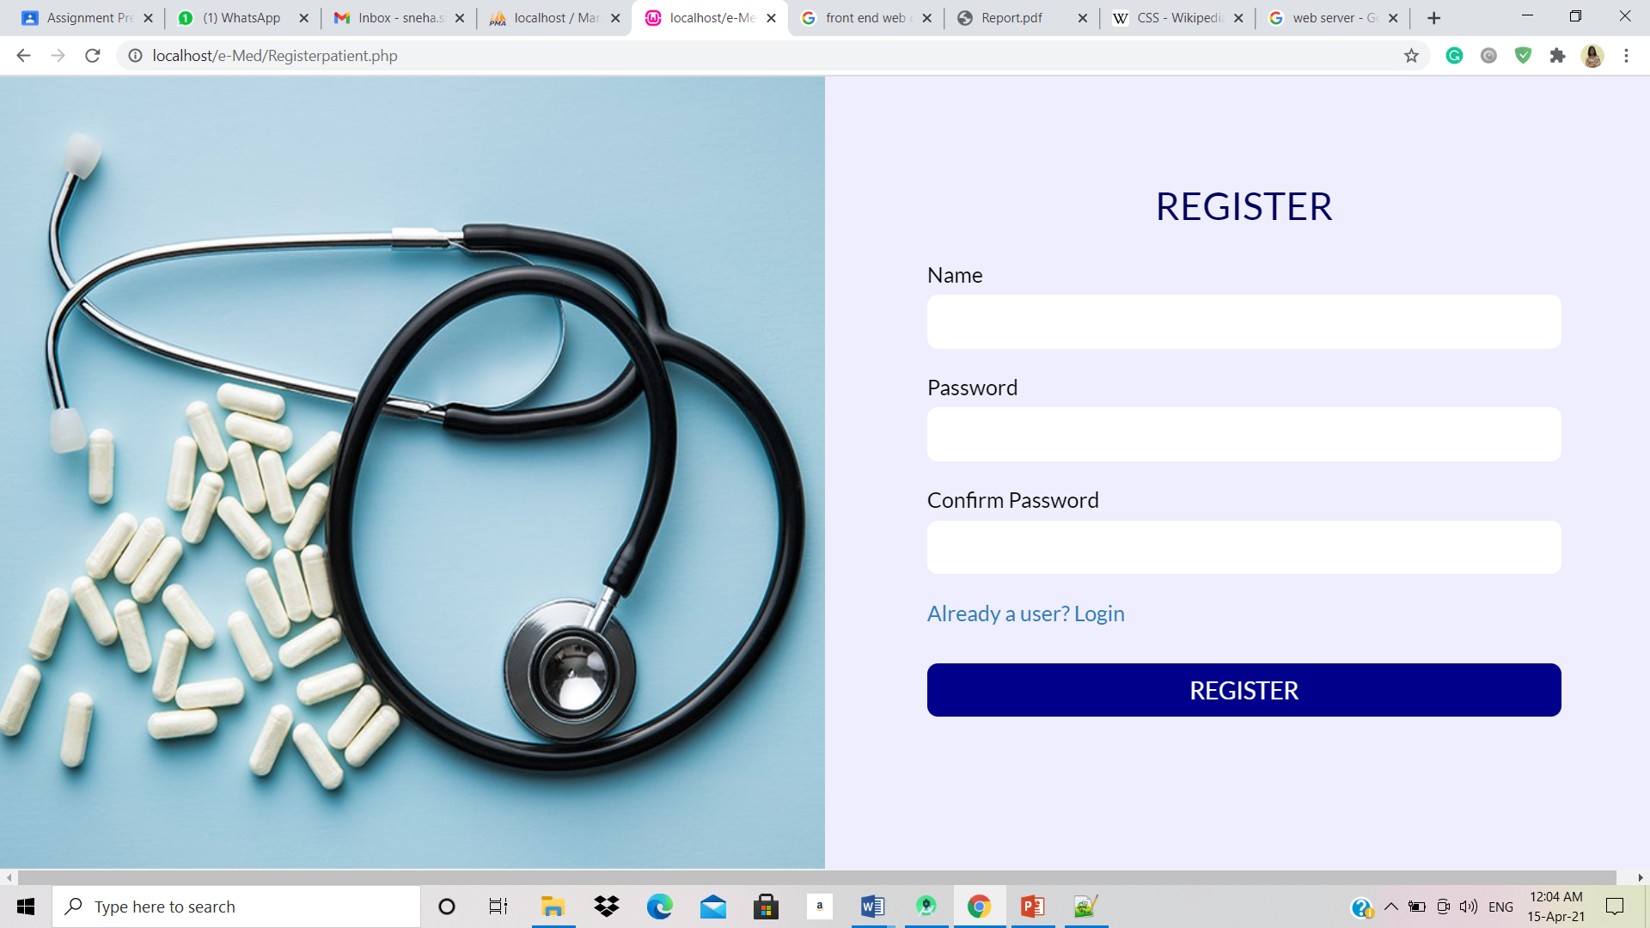

**Fig 10:** Patients can register with their name as username and a password.

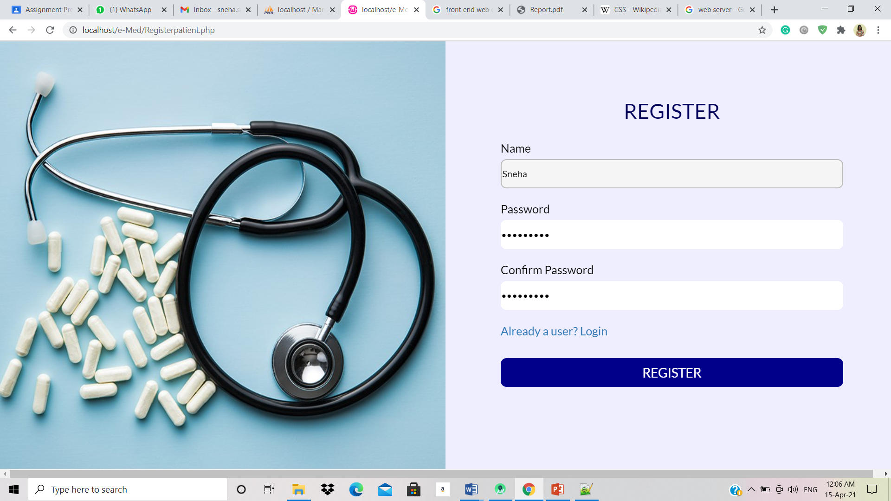

**Fig 11:** An account will be created if the details entered are correct.

**Register Receptionist**

<?php

session_start();

if(isset($_SESSION['register_error1']))

{

echo '<script type="text/javascript">window.onload = function(){alert("Failed to register")};</script>';

unset($_SESSION['register_error1']);

}

if(isset($_SESSION['register_error2']))

{

echo '<script type="text/javascript">window.onload = function(){alert("Password and confirm password does not match")};</script>';

unset($_SESSION['register_error2']);

}

?>

<!DOCTYPE html>

<html>

<head>

<meta name="viewport" content="width=device-width, initial-scale=1">

<link rel="stylesheet" href="https://maxcdn.bootstrapcdn.com/bootstrap/3.4.1/css/bootstrap.min.css">

<script src="https://ajax.googleapis.com/ajax/libs/jquery/3.5.1/jquery.min.js"></script>

<script src="https://maxcdn.bootstrapcdn.com/bootstrap/3.4.1/js/bootstrap.min.js"></script>

<link rel="preconnect" href="https://fonts.gstatic.com">

<link href="https://fonts.googleapis.com/css2?family=Lato:wght@400&display=swap" rel="stylesheet">

<style>

.column {

width:80%;

color:black;

margin-left:80px;

}

body

{

background-color: #EEEEFF;

background-image:url('stethoscope.jpg');

background-attachment:fixed;

background-size:50% 100%;

background-repeat:no-repeat;

font-family: 'Lato', sans-serif;

}

input[type="submit"]{

border-radius: 10px;

height:50px;

width: 100%;

background-color:#00008b;

color:white;

font-size:22px;

}

input[type="submit"]:hover{

border: #9932cc;

background-color: #0000cd;

cursor: pointer;

transition:0.6s;

}

input, select{

display:block;

width: 100%;

height: 50px;

padding: 5px 1px;

font-size:16px;

border-radius:10px;

outline:none;

margin: 5px 0 22px 0;

border: none;

background: #ffffff;

font-size:18px;

}

input:focus, textarea:focus, select:focus{

border: 2px solid #bbbbbb;

background: #f5f5f5;

transition: .6s;

outline:none;

}

form{

font-size:20px;

}

</style>

</head>

<body>

<div class="row">

<div class="col-sm-6">

</div>

<div class="col-sm-6" style="position: fixed;top: 11%;left: 50%;">

<div class="column">

<h1 style="text-align:center;color:#00005b;">REGISTER</h1>

<form method="POST" action="registerrectest.php">

Hospital Name

<input type="text" name="hospname" required>

Password

<input type="password" name="password" required>

Confirm Password

<input type="password" name="conf-pass" required>

<a style="text-decoration:none" href="Login.php" id="forgot">Already a user? Login</a><br><br>

<input type="submit" name="submit" value="REGISTER">

</form>

</div>

</div>

</div>

</body>

</html>

**Register Receptionist Test**

<?php

session_start();

$servername="localhost";

$username="root";

$password="";

$dbname="e-med";

$conn=new mysqli($servername,$username,$password,$dbname);

if (!$conn)

{

die('Could not connect: ' . mysql_error());

}

if(isset($_POST['submit']))

{

$hospital=$_POST['hospname'];

$pwd=$_POST['password'];

$conf=$_POST['conf-pass'];

if($pwd==$conf)

{

$sql="insert into receptionistlogin(Hospital, Password) values('$hospital','$pwd')";

$result=$conn->query($sql);

if($result)

{

$_SESSION['username'] = $uname;

header('location:ReceptionistHome.php');

}

else

{

$_SESSION['register_error1']=1;

header('location:Registerreceptionist.php');

}

}

else

{

$_SESSION['register_error2']=1;

header('location:Registerreceptionist.php');

}

}

$conn->close();

?>

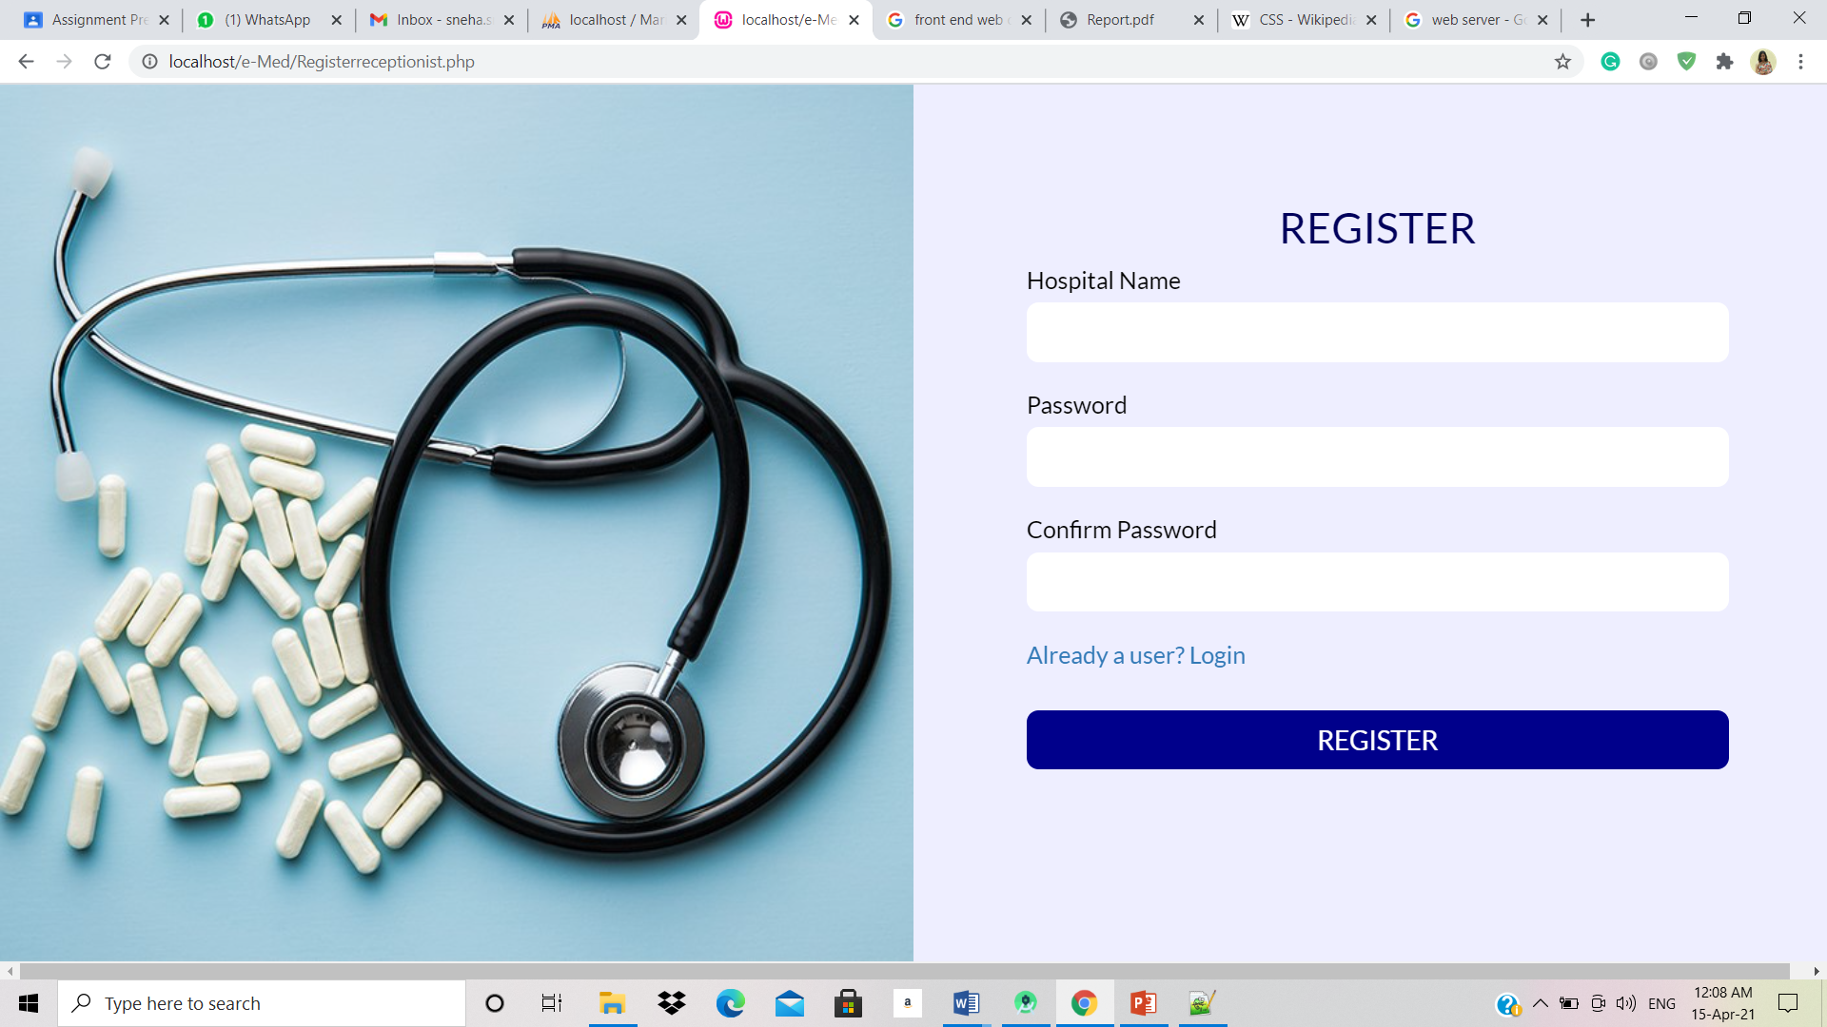

**Fig 12:** Receptionists can register with their hospital name as username and a password.

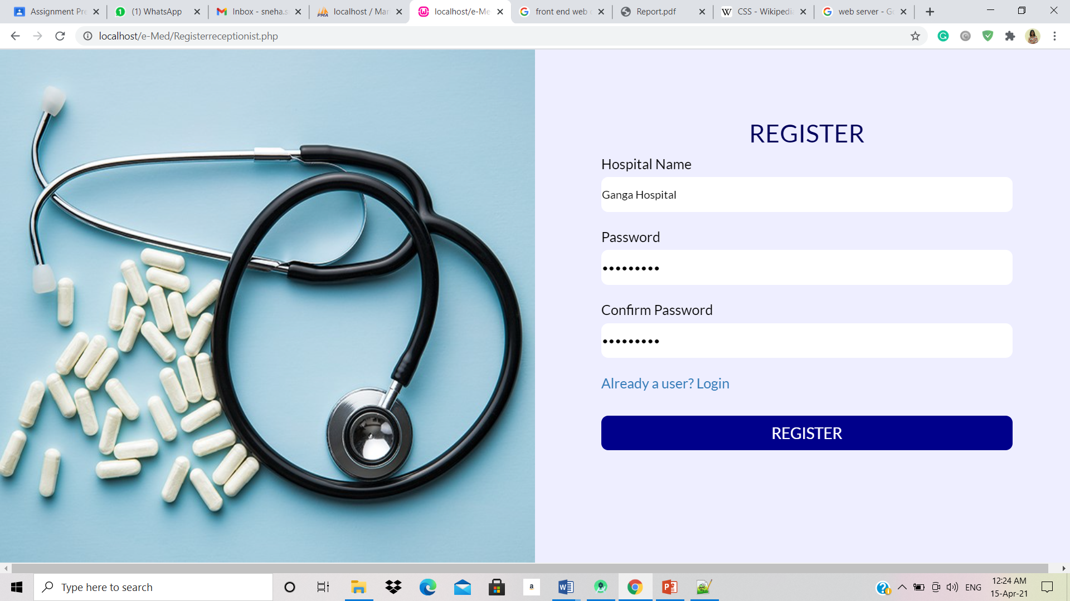

**Fig 13:** An account will be created if the details entered are correct.

**4.3 PATIENT MODULE**

**Patient Home**

<?php

session_start();

?>

<!DOCTYPE html>

<html>

<head>

<meta name="viewport" content="width=device-width, initial-scale=1">

<link rel="stylesheet" href="https://maxcdn.bootstrapcdn.com/bootstrap/3.4.1/css/bootstrap.min.css">

<script src="https://ajax.googleapis.com/ajax/libs/jquery/3.5.1/jquery.min.js"></script>

<script src="https://maxcdn.bootstrapcdn.com/bootstrap/3.4.1/js/bootstrap.min.js"></script>

<link rel="preconnect" href="https://fonts.gstatic.com">

<link href="https://fonts.googleapis.com/css2?family=Josefin+Sans&display=swap" rel="stylesheet">

<link href="https://fonts.googleapis.com/css2?family=Lato:wght@400&display=swap" rel="stylesheet">

<style>

body, html {

height: 100%;

font-family: 'Lato', sans-serif;

}

* {

box-sizing: border-box;

}

.bg-text {

position: absolute;

top: 67%;

z-index: 2;

padding: 20px;

}

.bg-image

{

height: 65%;

background-image:url('Homepage.jpg');

background-size:100% 100%;

background-repeat:no-repeat;

filter: blur(0px);

}

input,textarea{

padding: 10px;

display:block;

width: 90%;

height: 50px;

padding: 5px 1px;

font-size:16px;

border-radius:10px;

outline:none;

margin: 5px 0 22px 0;

border: none;

background: #ffffff;

font-size:18px;

}

input[type="submit"]{

border-radius: 10px;

height:50px;

width: 100px;

background-color:#00008b;

color:white;

font-size:22px;

display: inline-block;

}

input[type="submit"]:hover{

border: #9932cc;

background-color: #0000cd;

cursor: pointer;

transition:0.6s;

}

textarea

{

height:520px;

}

input:focus, textarea:focus, select:focus{

border: 2px solid #bbbbbb;

background: #f5f5f5;

transition: .6s;

outline:none;

}

form{

font-size:20px;

margin-left:70px;

}

h1{

color:#00005b;

text-align: center;

font-family: 'Josefin Sans', sans-serif;

font-size: 60px;

display: inline-block;

margin-right:50px;

}

h2{

color:#00005b;

text-align: center;

font-family: 'Josefin Sans', sans-serif;

font-size: 40px;

display: inline-block;

}

h3{

text-align: center;

font-size: 35px;

margin-top: 130px;

font-family: 'Josefin Sans', sans-serif;

color: #00005b;

}

.centered{

text-align: center;

}

.card{

background-color: #aaaaaa;

padding: 20px;

border-radius: 10px;

height: 150px;

width: 285px;

box-shadow: 0 4px 8px 0 rgba(0,0,0,0.2);

transition: 0.3s;

display:inline-block;

margin-left:47px;

margin-right:33px;

}

.card:hover {

box-shadow: 0 8px 16px 0 rgba(0,0,0,0.2);

background-color: #cccccc;

}

.card-text {

margin-top: 40px;

font-size: 20px;

color: #33335b;

}

a{

text-decoration: none;

}

footer {

text-align: center;

padding: 3px;

font-size: 17px;

background-color: #aaaaaa;

color: white;

}

</style>

</head>

<body>

<a href="Logout.php" role="button" class="btn btn-link" style="margin-left:95%;">Logout</a>

<div class="centered">

<h1>e-Med</h1>

<h2>Your personal health partner</h2>

</div>

<div class="bg-image"></div>

<div class="bg-text">

<a href="AddNotification.php">

<div class="card text-center stretched-link text-decoration-none">

<div class="card-body">

<p class="card-text">Add Notification</p>

</div>

</div>

</a>

<a href="BookAppointment.php">

<div class="card text-center stretched-link text-decoration-none">

<div class="card-body">

<p class="card-text">Book Appointment</p>

</div>

</div> </a>

<a href="ViewAppointments.php">

<div class="card text-center stretched-link text-decoration-none">

<div class="card-body">

<p class="card-text">View Appointments</p>

</div>

</div> </a>

<a href="AddNotes.php">

<div class="card text-center stretched-link text-decoration-none">

<div class="card-body">

<p class="card-text">Medical Notes</p>

</div>

</div> </a>

</div>

<h3>Your Notifications</h3><br>

<?php

$name=$_SESSION['username'];

$servername = "localhost";

$username = "root";

$password = "";

$dbname = "e-med";

$conn = new mysqli($servername, $username, $password, $dbname);

if (!$conn)

{

die("Connection failed: ".mysql_error());

}

$sql = "SELECT Notification FROM notification WHERE Uname='$name' and Remdate=CURDATE()";

$result = mysqli_query($conn, $sql);

if (mysqli_num_rows($result)>0)

{

while($row = mysqli_fetch_assoc($result))

{

echo '<div style="margin-left: 15%; width: 70%;">';

echo '<ul class="list-group list-group-flush" style="font-size:19px;">';

echo '<li class="list-group-item">'.$row['Notification'].'</li>';

echo '</ul></div>';

}

}

else {

echo '<div style="margin-left: 15%; width: 70%;">';

echo '<ul class="list-group list-group-flush" style="font-size:19px;">';

echo '<li class="list-group-item">No Notifications</li>';

echo '</ul></div>';

} ?><br><br><br>

<footer>

<p>&copy; Author: Sneha Sridharan<br>

Contact Number: 2382378271</p>

</footer>

</body>

</html>

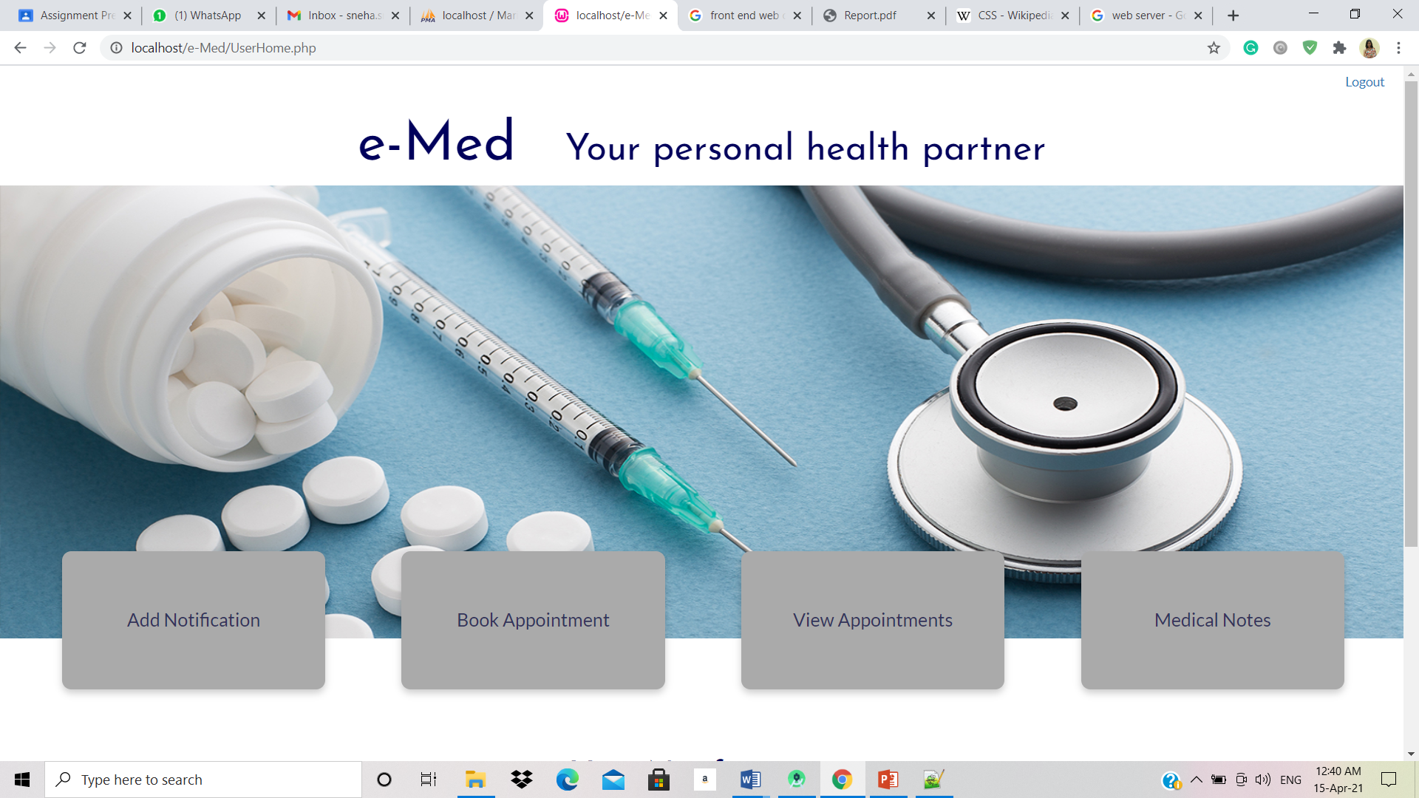 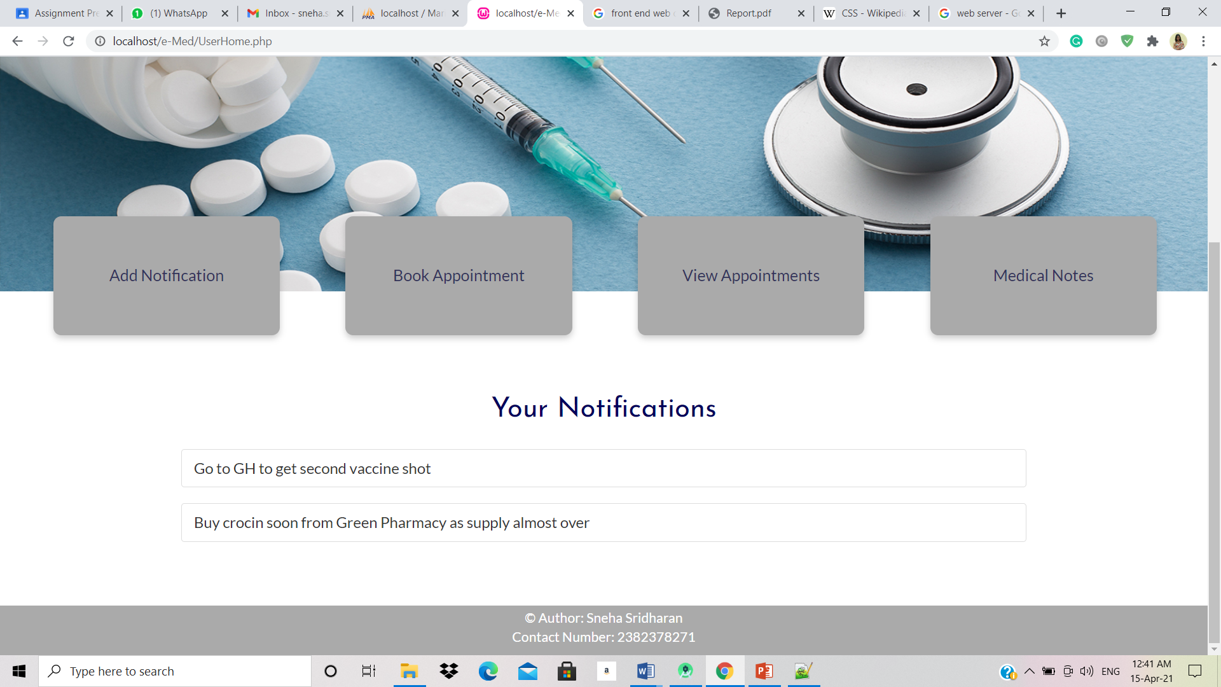

**Fig 14:** Patient home page where patients can view their notifications and perform one or more of the tasks specified.

**Add Notification**

<?php

session_start();

if(isset($_SESSION['add_notification_error']))

{

echo '<script type="text/javascript">window.onload = function(){alert("Error while creating notification. Please try again")};</script>';

unset($_SESSION['add_notification_error']);

}

?>

<!DOCTYPE html>

<html>

<head>

<meta name="viewport" content="width=device-width, initial-scale=1">

<link rel="stylesheet" href="https://maxcdn.bootstrapcdn.com/bootstrap/3.4.1/css/bootstrap.min.css">

<script src="https://ajax.googleapis.com/ajax/libs/jquery/3.5.1/jquery.min.js"></script>

<script src="https://maxcdn.bootstrapcdn.com/bootstrap/3.4.1/js/bootstrap.min.js"></script>

<link rel="preconnect" href="https://fonts.gstatic.com">

<link href="https://fonts.googleapis.com/css2?family=Lato:wght@400&display=swap" rel="stylesheet">

<style>

body, html {

height: 100%;

font-family: 'Lato', sans-serif;

}

* {

box-sizing: border-box;

}

.bg-text {

background-color: #EEEEFF;

position: absolute;

top: 50%;

left: 60%;

transform: translate(-50%, -50%);

z-index: 2;

width: 65%;

padding: 20px;

height:80%;

}

.bg-image

{

height:100%;

background-image:url('medical.jpg');

background-size:100% 100%;

background-repeat:no-repeat;

filter: blur(0px);

}

input,textarea{

margin: 5px 0 22px 0;

border: none;

background: #ffffff;

font-size:18px;

display:block;

width: 90%;

height: 50px;

padding: 5px 1px;

font-size:16px;

border-radius:10px;

outline:none;

}

input[type="submit"]{

border-radius: 10px;

height:50px;

width: 90%;

background-color:#00008b;

color:white;

font-size:22px;

}

input[type="submit"]:hover{

border: #9932cc;

background-color: #0000cd;

cursor: pointer;

transition:0.6s;

}

textarea

{

height:100px;

}

input:focus, textarea:focus, select:focus{

border: 2px solid #bbbbbb;

background: #f5f5f5;

transition: .6s;

outline:none;

}

form{

font-size:20px;

margin-left:70px;

}

</style>

</head>

<body>

<div class="bg-image"></div>

<div class="bg-text">

<h1 style="text-align:center;color:#00005b;">ADD NOTIFICATION</h1><br><br>

<form method="POST" action="NotificationTest.php">

Notification

<textarea id="notification" name="notification" required></textarea>

<br>

Reminder Date

<input type="date" name="date" required><br><br>

<input type="submit" name="submit" value="ADD">

</form>

</div>

</body>

</html>

**Add Notification Test**

<?php

session_start();

$servername="localhost";

$username="root";

$password="";

$dbname="e-med";

$conn=new mysqli($servername,$username,$password,$dbname);

if (!$conn)

{

die('Could not connect: ' . mysql_error());

}

if(isset($_POST['submit']))

{

$notification=$_POST['notification'];

$name=$_SESSION['username'];

$date=$_POST['date'];

$sql="insert into notification(Notification, Remdate, Uname) values('$notification','$date','$name')";

$result=mysqli_query($conn,$sql);

if($result)

{

header('Location:UserHome.html');

}

else

{

$_SESSION['add_notification_error'] = 1;

header('Location:AddNotification.php');

}

}

?>

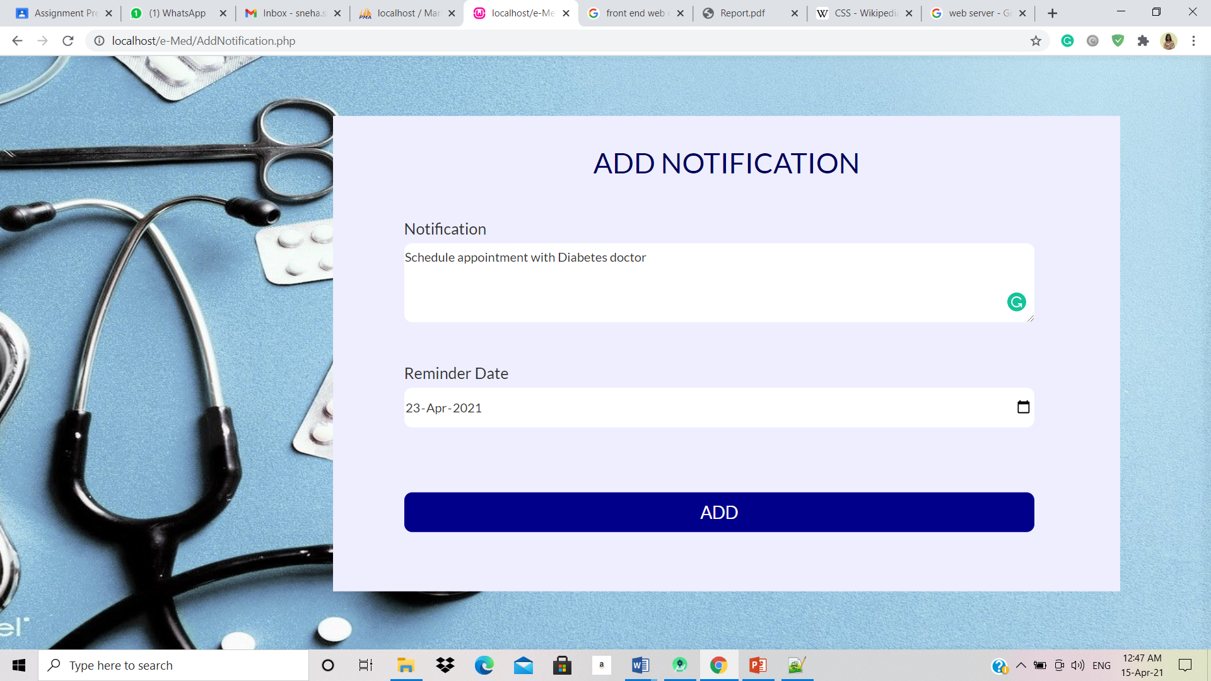

**Fig 15:** Patients can add notifications by specifying the notification text and reminder date.

**Book Appointment**

<?php

session_start();

if(isset($_SESSION['book_apptmnt_error']))

{

echo '<script type="text/javascript">window.onload = function(){alert("Error while booking appointment. Please try again")};</script>';

unset($_SESSION['book_apptmnt_error']);

}

?>

<!DOCTYPE html>

<html>

<head>

<meta name="viewport" content="width=device-width, initial-scale=1">

<link rel="stylesheet" href="https://maxcdn.bootstrapcdn.com/bootstrap/3.4.1/css/bootstrap.min.css">

<script src="https://ajax.googleapis.com/ajax/libs/jquery/3.5.1/jquery.min.js"></script>

<script src="https://maxcdn.bootstrapcdn.com/bootstrap/3.4.1/js/bootstrap.min.js"></script>

<link rel="preconnect" href="https://fonts.gstatic.com">

<link href="https://fonts.googleapis.com/css2?family=Lato:wght@400&display=swap" rel="stylesheet">

<style>

body, html {

height: 100%;

font-family: 'Lato', sans-serif;

}

* {

box-sizing: border-box;

}

.bg-text {

background-color: #EEEEFF;

position: absolute;

top: 50%;

left: 67.5%;

transform: translate(-50%, -50%);

z-index: 2;

width: 65%;

padding: 20px;

height:100%;

}

.bg-image

{

height:100%;

background-image:url('medical.jpg');

background-size:100% 100%;

background-repeat:no-repeat;

filter: blur(0px);

}

input[type="submit"]{

border-radius: 10px;

height:50px;

width: 90%;

background-color:#00008b;

color:white;

font-size:22px;

}

input[type="submit"]:hover{

border: #9932cc;

background-color: #0000cd;

cursor: pointer;

transition:0.6s;

}

input, select{

display:block;

width: 90%;

height: 50px;

padding: 5px 1px;

font-size:16px;

border-radius:10px;

outline:none;

margin: 5px 0 22px 0;

border: none;

background: #ffffff;

font-size:18px;

}

input:focus, textarea:focus, select:focus{

border: 2px solid #bbbbbb;

background: #f5f5f5;

transition: .6s;

outline:none;

}

form{

font-size:20px;

margin-left:70px;

}

</style>

</head>

<body>

<div class="bg-image"></div>

<div class="bg-text">

<h1 style="text-align:center;color:#00005b;">BOOK APPOINTMENT</h1><br><br>

<form method="POST" action="BookAppointmentTest.php">

Hospital

<input type="text" name="hospital" required>

<br>

Date

<input type="date" name="date" required>

<br>

Time

<input type="time" name="time" required><br><br>

<input type="submit" name="submit" value="BOOK">

</form>

</div>

</body>

</html>

**Book Appointment Test**

<?php

session_start();

$servername="localhost";

$username="root";

$password="";

$dbname="e-med";

$conn=new mysqli($servername,$username,$password,$dbname);

if (!$conn)

{

die('Could not connect: ' . mysql_error());

}

if(isset($_POST['submit']))

{

$hospital=$_POST['hospital'];

$date=$_POST['date'];

$time=$_POST['time'];

$name=$_SESSION['username'];

$sql="insert into appointment(Hospital, Date, Time, Uname) values('$hospital','$date','$time','$name')";

$result=mysqli_query($conn,$sql);

if($result)

{

header('Location:UserHome.php');

}

else

{

$_SESSION['book_apptmnt_error'] = 1;

header('Location:BookAppointment.php');

}

}

?>

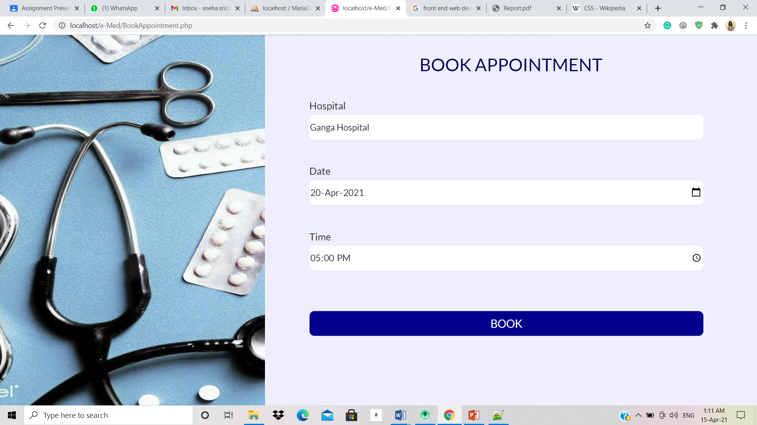

**Fig 16:** Patients can book appointments with hospital name, date and time.

**View Appointment**

<?php

session_start();

?>

<!DOCTYPE html>

<html>

<head>

<meta name="viewport" content="width=device-width, initial-scale=1">

<link rel="stylesheet" href="https://maxcdn.bootstrapcdn.com/bootstrap/3.4.1/css/bootstrap.min.css">

<script src="https://ajax.googleapis.com/ajax/libs/jquery/3.5.1/jquery.min.js"></script>

<script src="https://maxcdn.bootstrapcdn.com/bootstrap/3.4.1/js/bootstrap.min.js"></script>

<link rel="preconnect" href="https://fonts.gstatic.com">

<link href="https://fonts.googleapis.com/css2?family=Lato:wght@400&display=swap" rel="stylesheet">

<style>

body, html {

height: 100%;

font-family: 'Lato', sans-serif;

}

* {

box-sizing: border-box;

}

.bg-text {

background-color: #EEEEFF;

position: absolute;

top: 50%;

left: 67.5%;

transform: translate(-50%, -50%);

z-index: 2;

width: 65%;

padding: 20px;

height:100%;

}

.bg-image

{

height:100%;

background-image:url('medical.jpg');

background-size:100% 100%;

background-repeat:no-repeat;

filter: blur(0px);

}

input[type="submit"]{

border-radius: 10px;

height:50px;

width: 90%;

background-color:#00008b;

color:white;

font-size:22px;

}

input[type="submit"]:hover{

border: #9932cc;

background-color: #0000cd;

cursor: pointer;

transition:0.6s;

}

input, select{

display:block;

width: 90%;

height: 50px;

padding: 5px 1px;

font-size:16px;

border-radius:10px;

outline:none;

margin: 5px 0 22px 0;

border: none;

background: #ffffff;

font-size:18px;

}

input:focus, textarea:focus, select:focus{

border: 2px solid #bbbbbb;

background: #f5f5f5;

transition: .6s;

outline:none;

}

form{

font-size:20px;

margin-left:70px;

}

.card{

background-color: #f3f3f3;

padding: 20px;

border-radius: 10px;

width: 90%;

box-shadow: 0 4px 8px 0 rgba(0,0,0,0.2);

transition: 0.3s;

display:inline-block;

margin-left:47px;

margin-top:33px;

}

.card-text {

font-size: 20px;

}

</style>

</head>

<body>

<div class="bg-image"></div>

<div class="bg-text">

<h1 style="margin-left: 5%; color: #00008b;">View Appointments</h1>

<div class="bg-image"></div>

<div class="bg-text">

<h1 style="margin-left: 5%; color: #00008b;">View Appointments</h1>

<?php

$name=$_SESSION['username'];

$servername = "localhost";

$username = "root";

$password = "";

$dbname = "e-med";

$conn = new mysqli($servername, $username, $password, $dbname);

if (!$conn)

{

die("Connection failed: ".mysql_error());

}

$sql = "SELECT * FROM appointment WHERE Uname='$name' and Date>=CURDATE()";

$result = mysqli_query($conn, $sql);

if (mysqli_num_rows($result)>0)

{

while($row = mysqli_fetch_assoc($result))

{

echo '<div class="card">';

echo '<div class="card-body">';

echo '<div class="card-text">';

echo '<p>Hospital: '.$row['Hospital'].'</p>';

echo '<p>Date: '.date("d-m-Y", strtotime($row['Date'])).'</p>';

echo '<p>Time: '.$row['Time'].'</p>';

echo '<p>Status: '.$row['Status'].'</p>';

echo '</div>';

echo '</div>';

echo '</div>';

}

}

?>

</div>

</body>

</html>

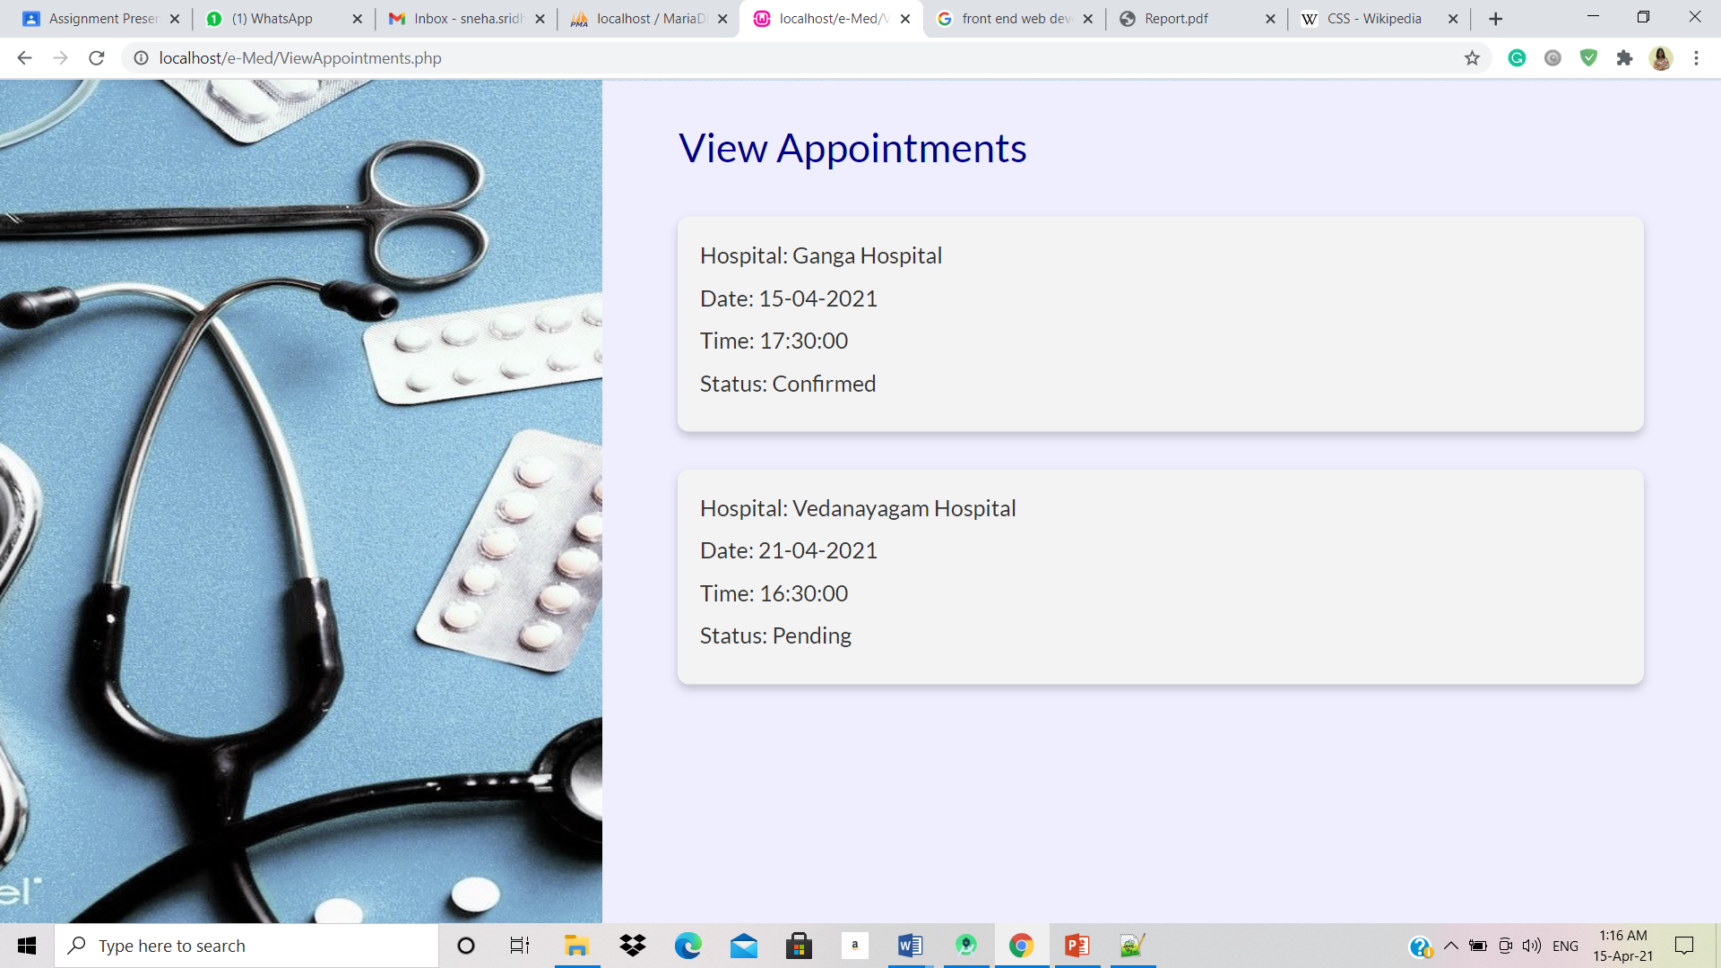

**Fig 17:** Users can see their appointments and their status in this page.

**Add Notes**

<?php

session_start();

if(isset($_SESSION['add_notes_error']))

{

echo '<script type="text/javascript">window.onload = function(){alert("Error while saving notes. Please try again")};</script>';

unset($_SESSION['add_notes_error']);

}

?>

<!DOCTYPE html>

<html>

<head>

<meta name="viewport" content="width=device-width, initial-scale=1">

<link rel="stylesheet" href="https://maxcdn.bootstrapcdn.com/bootstrap/3.4.1/css/bootstrap.min.css">

<script src="https://ajax.googleapis.com/ajax/libs/jquery/3.5.1/jquery.min.js"></script>

<script src="https://maxcdn.bootstrapcdn.com/bootstrap/3.4.1/js/bootstrap.min.js"></script>

<link rel="preconnect" href="https://fonts.gstatic.com">

<link href="https://fonts.googleapis.com/css2?family=Lato:wght@400&display=swap" rel="stylesheet">

<style>

body, html {

height: 100%;

font-family: 'Lato', sans-serif;

}

* {

box-sizing: border-box;

}

.bg-text {

background-color: #EEEEFF;

position: absolute;

top: 50%;

left: 67.5%;

transform: translate(-50%, -50%);

z-index: 2;

width: 65%;

padding: 20px;

height:100%;

}

.bg-image

{

height:100%;

background-image:url('medical.jpg');

background-size:100% 100%;

background-repeat:no-repeat;

filter: blur(0px);

}

input, textarea{

margin: 5px 0 22px 0;

border: none;

background: #ffffff;

font-size:18px;

display:block;

width: 90%;

height: 50px;

padding: 5px 1px;

font-size:16px;

border-radius:10px;

outline:none;

}

input[type="submit"]{

border-radius: 10px;

height:50px;

width: 100px;

background-color:#00008b;

color:white;

font-size:22px;

display: inline-block;

}

input[type="submit"]:hover{

border: #9932cc;

background-color: #0000cd;

cursor: pointer;

transition:0.6s;

}

textarea

{

height:520px;

}

input:focus, textarea:focus, select:focus{

border: 2px solid #bbbbbb;

background: #f5f5f5;

transition: .6s;

outline:none;

}

form{

font-size:20px;

margin-left:70px;

}

</style>

</head>

<body>

<div class="bg-image"></div>

<div class="bg-text">

<form method="POST" action="AddNotesTest.php">

<div class="row">

<h1 style="color:#00005b;margin:40px 410px 0px 15px;display:inline-block;">MEDICAL NOTES</h1>

<input type="submit" name="submit" value="SAVE">

</div><br>

<?php

$name=$_SESSION['username'];

$servername = "localhost";

$username = "root";

$password = "";

$dbname = "e-med";

$conn = new mysqli($servername, $username, $password, $dbname);

if (!$conn)

{

die("Connection failed: ".mysql_error());

}

$sql = "SELECT Notes FROM notes WHERE Uname='$name'";

$result = mysqli_query($conn, $sql);

if($result)

$row = $result->fetch_assoc();

?>

<textarea id="notes" name="notes" required><?php if($result){echo $row['Notes'];}?></textarea><br>

</form>

</div>

</body>

</html>

**Add Notes Test**

<?php

session_start();

$servername="localhost";

$username="root";

$password="";

$dbname="e-med";

$conn=new mysqli($servername,$username,$password,$dbname);

if (!$conn)

{

die('Could not connect: ' . mysql_error());

}

if(isset($_POST['submit']))

{

$notes=$_POST['notes'];

$name=$_SESSION['username'];

$sql="select * from notes WHERE Uname = '$name'";

$result=$conn->query($sql);

if(mysqli_num_rows($result)==0)

{

$sql1="insert into notes values('$notes','$name')";

$result1=mysqli_query($conn,$sql1);

if($result1)

{

header('Location:AddNotes.php');

}

else

{

$_SESSION['add_notes_error'] = 1;

header('Location:AddNotes.php');

}

}

else

{

$sql1="update notes set Notes='$notes' where Uname='$name'";

$result1=mysqli_query($conn,$sql1);

if($result1)

{

header('Location:AddNotes.php');

}

else

{

$_SESSION['add_notes_error'] = 1;

header('Location:AddNotes.php');

}

}

}

?>

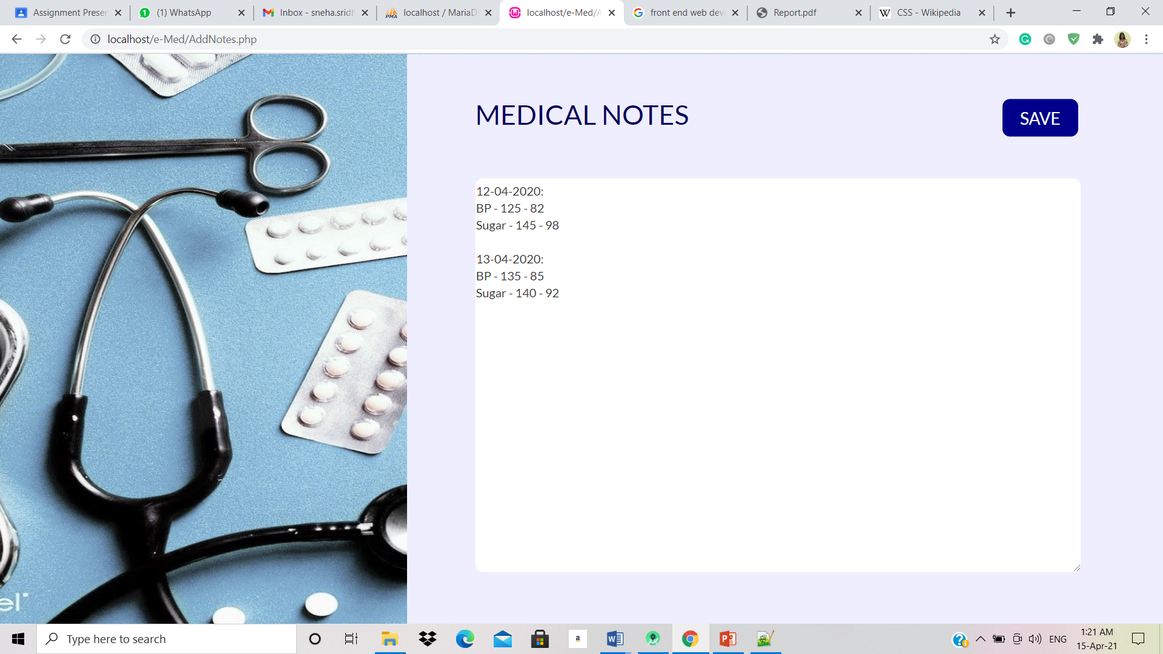

**Fig 18:** Patients can add and update their notes here.

**4.3 HOSPITAL MODULE**

**Receptionist Home**

<?php

session_start();

if(isset($_SESSION['status_error']))

{

echo '<script type="text/javascript">window.onload = function(){alert("Error while updating status. Please try again")};</script>';

unset($_SESSION['status_error']);

}

?>

<!DOCTYPE html>

<html>

<head>

<meta name="viewport" content="width=device-width, initial-scale=1">

<link rel="stylesheet" href="https://maxcdn.bootstrapcdn.com/bootstrap/3.4.1/css/bootstrap.min.css">

<script src="https://ajax.googleapis.com/ajax/libs/jquery/3.5.1/jquery.min.js"></script>

<script src="https://maxcdn.bootstrapcdn.com/bootstrap/3.4.1/js/bootstrap.min.js"></script>

<link rel="preconnect" href="https://fonts.gstatic.com">

<link href="https://fonts.googleapis.com/css2?family=Josefin+Sans&display=swap" rel="stylesheet">

<link href="https://fonts.googleapis.com/css2?family=Lato:wght@400&display=swap" rel="stylesheet">

<style>

body, html {

height: 100%;

font-family: 'Lato', sans-serif;

}

* {

box-sizing: border-box;

}

.bg-text {

position: absolute;

top: 67%;

z-index: 2;

padding: 20px;

}

.bg-image

{

height: 65%;

background-image:url('Homepage.jpg');

background-size:100% 100%;

background-repeat:no-repeat;

filter: blur(0px);

}

input,textarea{

margin: 5px 0 22px 0;

border: none;

background: #ffffff;

font-size:18px;

display:block;

width: 90%;

height: 50px;

padding: 5px 1px;

font-size:16px;

border-radius:10px;

outline:none;

}

input[type="submit"]{

border-radius: 10px;

height:50px;

width: 100px;

background-color:#00008b;

color:white;

font-size:22px;

display: inline-block;

}

input[type="submit"]:hover{

border: #9932cc;

background-color: #0000cd;

cursor: pointer;

transition:0.6s;

}

textarea

{

height:520px;

}

input:focus, textarea:focus, select:focus{

border: 2px solid #bbbbbb;

background: #f5f5f5;

transition: .6s;

outline:none;

}

form{

font-size:20px;

margin-left:70px;

}

h1{

color:#00005b;

text-align: center;

font-family: 'Josefin Sans', sans-serif;

font-size: 60px;

display: inline-block;

margin-right:50px;

}

h2{

color:#00005b;

text-align: center;

font-family: 'Josefin Sans', sans-serif;

font-size: 40px;

display: inline-block;

}

h3{

text-align: center;

font-size: 35px;

font-family: 'Josefin Sans', sans-serif;

color: #00005b;

}

.centered{

text-align: center;

}

.card{

background-color: #f3f3f3;

padding: 20px;

border-radius: 10px;

width: 90%;

box-shadow: 0 4px 8px 0 rgba(0,0,0,0.2);

transition: 0.3s;

display:inline-block;

margin-left:47px;

margin-top:33px;

}

.card-text {

font-size: 20px;

}

a{

text-decoration: none;

display: inline-block;

}

footer {

text-align: center;

padding: 3px;

font-size: 17px;

background-color: #aaaaaa;

color: white;

}

</style>

</head>

<body>

<a href="Logout.php" role="button" class="btn btn-link" style="margin-left:95%;">Logout</a>

<div class="centered">

<h1>e-Med</h1>

<h2>Your personal health partner</h2>

</div>

<div class="bg-image"></div><br>

<h3>Appointments</h3><br>

<div class="card">

<div class="card-body">

<div class="card-text">

<?php

$name=$_SESSION['username'];

$servername = "localhost";

$username = "root";

$password = "";

$dbname = "e-med";

$conn = new mysqli($servername, $username, $password, $dbname);

if (!$conn)

{

die("Connection failed: ".mysql_error());

}

$sql = "SELECT * FROM appointment WHERE Hospital='$name'";

$result = mysqli_query($conn, $sql);

if (mysqli_num_rows($result)>0) {

while($row = mysqli_fetch_assoc($result))

{

$id=$row['AppointmentID'];

$accept='Confirmed';

$reject='Unavailable';

echo '<p>Patient: '.$row['Uname'].'</p>';

echo '<p>Date: '.date("d-m-Y", strtotime($row['Date'])).'</p>';

echo '<p>Time: '.$row['Time'].'</p>';

if($row['Status']=='Pending') {

echo "<a href='StatusChange.php?id=$id&status=$accept' role='button' class='btn btn-primary' style='margin-left:86%;'>Confirm</a>";

echo "<a href='StatusChange.php?id=$id&status=$reject' role='button' class='btn btn-primary' style='margin-left:1%;'>Unavailable</a>";

}

else

{

echo '<p>Status: '.$row['Status'].'</p>';

}

}

}

?>

</div>

</div>

</div>

<br><br><br>

<footer>

<p>&copy; Author: Sneha Sridharan<br>

Contact Number: 2382378271</p>

</footer>

</body>

</html>

**Status Change**

<?php

session_start();

$servername="localhost";

$username="root";

$password="";

$dbname="e-med";

$conn=new mysqli($servername,$username,$password,$dbname);

if (!$conn)

{

die('Could not connect: ' . mysql_error());

}

$id=$_GET['id'];

$status=$_GET['status'];

$sql="update appointment set Status='$status' where AppointmentID=$id";

$result=mysqli_query($conn,$sql);

if($result)

{

header('Location:ReceptionistHome.php');

}

else

{

$_SESSION['status_error'] = 1;

header('Location:ReceptionistHome.php');

}

?>

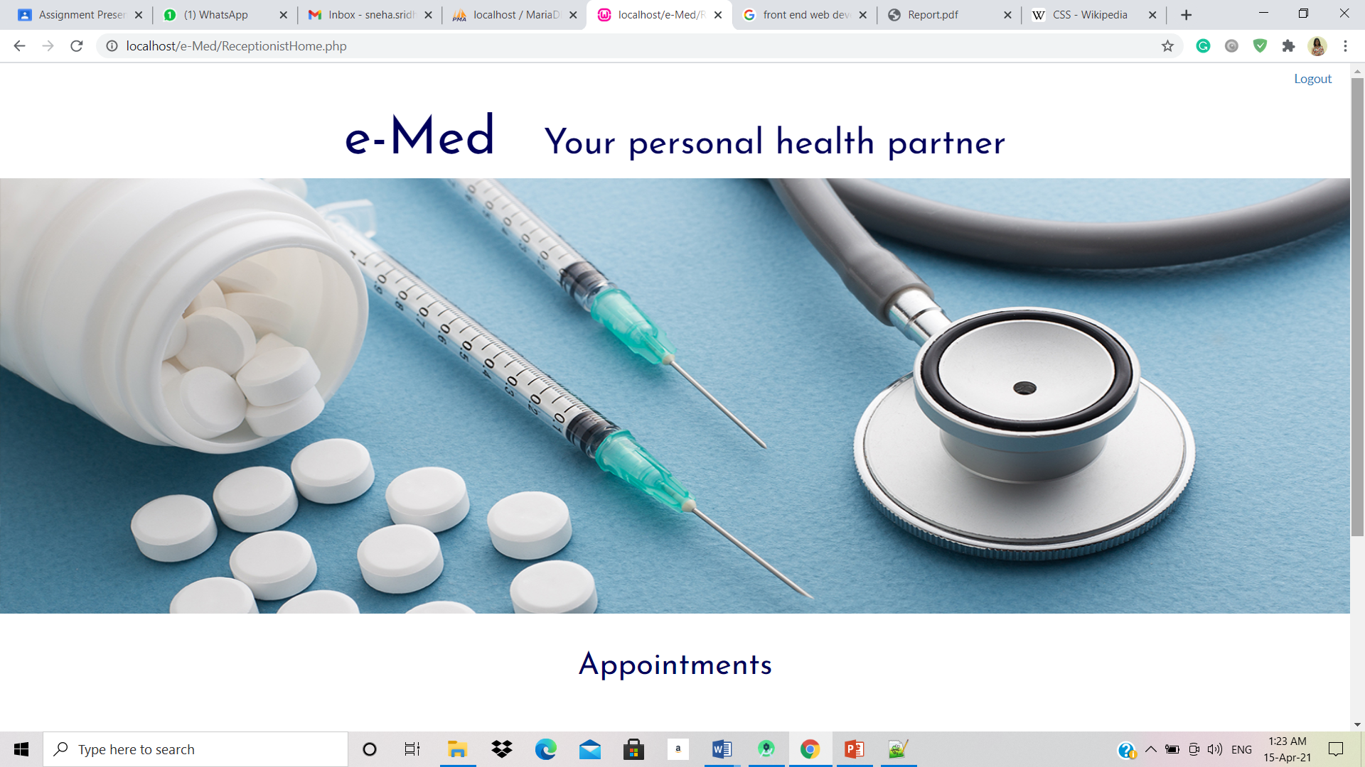 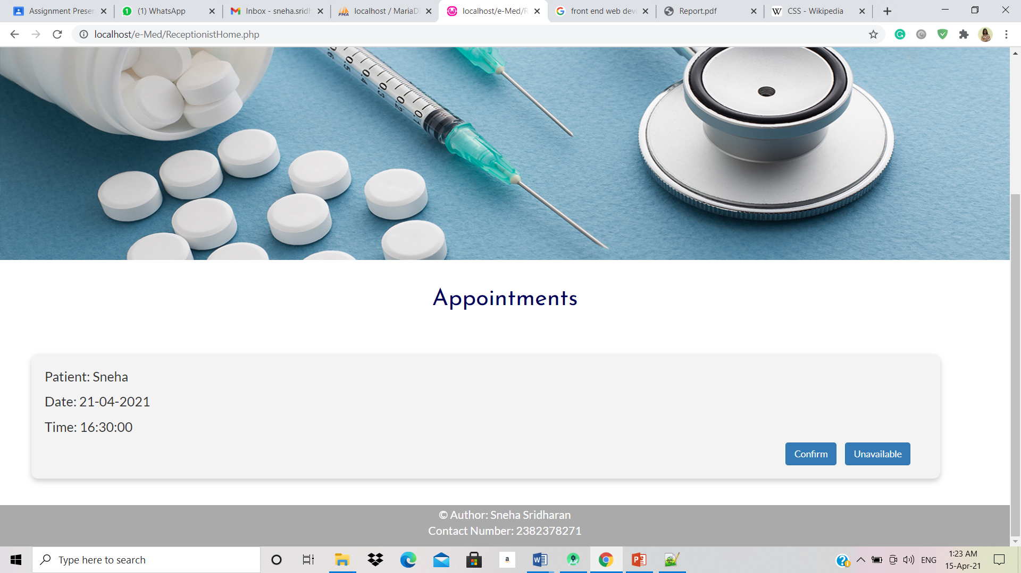

**Fig 19:** Receptionist of the hospital can check the appointments booked by the patients and change the status based on slot availability

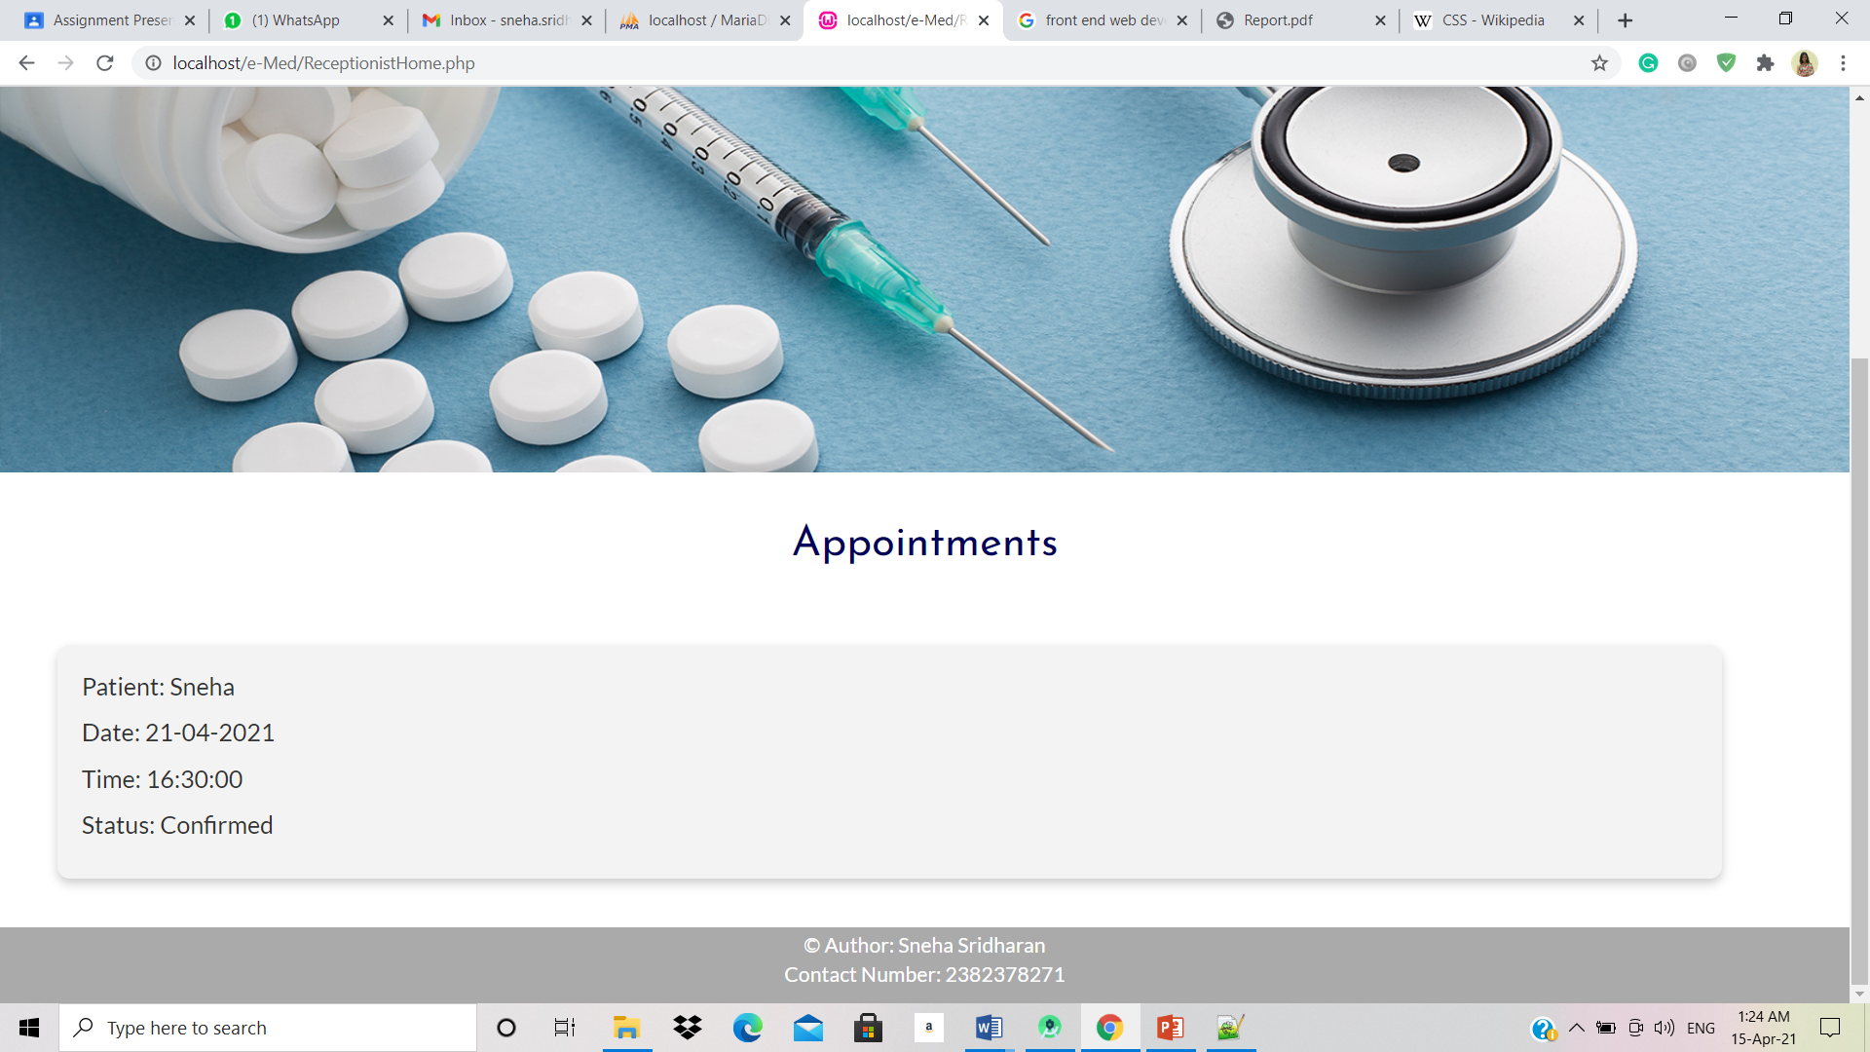

**Fig 20:** Appointments after updating status

**Logout**

<?php

session_start();

unset($_SESSION['username']);

header('Location:Login.php');

?>

Used to log out of the system. Log out option is there in both the home pages.